304243‑R00030

Revision C

ITER wide angle viewing system PROJECT

55.GA UWAVS Instrumentation and control architecture

**Sponsored by Oak Ridge National Laboratory**

**c/o Princeton Plasma Physics Laboratory**

**Under Subcontract No: S013437**

**Prepared by General Atomics**

**PO Box 85608**

**San Diego, CA 92186‑5608**

**GA PROJECT 30424**

REVISION HISTORY

|  |  |  |
| --- | --- | --- |
| Revision | Date | Description of Changes |
| A | 2024/06/25 | Initial Release |
| B | 2025/02/06 | Revised power collection and head load analysis table, added specs for IR and VIS cameras, added UWAVS measurement table with measurement number, updated software architecture diagram figure 41. |
| C | See Watermark | Comments received by the ITER Organization and recorded in IDM have been addressed individually and are tabulated in Appendix A. |

POINT OF CONTACT INFORMATION

|  |  |  |  |
| --- | --- | --- | --- |
| PREPARED BY: | | | |
| Name | Position | Email | Phone |
| Maithili Groh | I&C Engineer | Maithili.Groh@ga.com | 858‑455‑3315 |
| Daniel Finkenthal | I&C Engineer | dfinkenthal@palomarsci.com | 858‑455‑2354 |
| Sebastian Miranda | I&C Engineer | smiranda@palomarsci.com | 858‑455‑2345 |
| APPROVED BY: | | | |
| Name | Position | Email | Phone |
| Ramon Thomson | Quality Engineer | Ramon.Thomson@ga.com | 858‑455‑2968 |
| Sean McCartney | Lead Engineer | Sean.McCartney@ga.com | 858‑248‑6652 |
| Anthony Gattuso | Program Manager | Anthony.Gattuso@ga.com | 858‑455‑2910 |

TABLE OF CONTENTS

REVISION HISTORY ii

POINT OF CONTACT INFORMATION ii

ACRONYMS vi

1 Introduction 1

1.1 Purpose 1

1.2 UWAVS System Layout 1

1.3 UWAVS System Description 3

2 High‑Level Hardware Architecture 9

3 Independent UWAVS POrt Control System (Port 02, 08, 11, 14,17) 10

3.1 Control System Architecture 10

3.2 UWAVS Port Subsystem Design 14

3.3 Calibration Strategy 23

3.4 Mirror Cleaning System 33

3.5 Shutter Control System 39

3.6 Image Acquisition and Processing System 41

3.7 COTS Checklist 48

4 Cubicle configuration 55

4.1 Cubicle Layouts 55

4.2 Power Allocation and Heat Load Analysis 63

4.3 Cubicle Cooling Configuration 68

4.4 Cubicle Enclosure Types 68

4.5 Cubicle Cable Entries 68

4.6 Network Interface 68

4.7 LCC Bill of Material 69

4.8 Cubicle Locations 71

5 Earthing Concept 73

6 Software Architecture 74

6.1 Software Architecture Overview 74

6.2 UWAVS Software Flux 75

6.3 Fast Controller(s) Time Synchronization 76

6.4 UWAVS Software Architecture 77

6.5 Master Controller (Separate for each UWAVS port) 78

6.6 User Interface (HMI) 79

7 References 82

8 APPENDIX A A-1

LIST OF FIGURES

Figure 1. 55.GA ports around the tokamak 2

Figure 2. Illustration of a single 55.GA port 3

Figure 3. Illustration of the instrumentation and controls for 55.GA single port 6

Figure 4. Top level architecture representative of port 14 11

Figure 5. BEOC instrumentation and BEOC calibration sources location 13

Figure 6. 55.GA design breakdown into sub systems. 15

Figure 7. Active alignment signal chain 18

Figure 8. Active alignment system (a) Components (b) detailed instrumentation on A40 mirrors 19

Figure 9. A40‑M2 mirror subassembly physical architecture. Mirror (a) normal, (b) side, and (c) rear isometric views. Some components transparent for clarity. 20

Figure 10. Photos of a typical UWAVS mirror mount and radiation‑hardened stepper motor. 20

Figure 11. Photos of a typical UWAVS mirror mount and radiation‑hardened stepper motor. 21

Figure 12. Rad‑resistant miniature limit switch from Crouzet 21

Figure 13. Stepper Motor Control system components from Physik Instrumente 22

Figure 14. Different types of Calibrations during UWAVS measurement. 25

Figure 15. BEOC calibration source location with respect to cameras 27

Figure 16. Picture of the Model 458‑4 LED‑Standard Lamp with Integrating Sphere 27

Figure 17. Model M330 Blackbody Source (shown without customization) 28

Figure 18. Inside of the enclosed Model M330 Blackbody Source. The internal assemblies will be removed from the enclosure for integration directly in the BEOC. The controller will be located in the diagnostic hall. 29

Figure 19. Transmission monitoring filament control scheme 31

Figure 20. (a)First mirror locations and instrumentation in Bullnose (b) MIC cable routing to first mirrors delivering RF power 34

Figure 21. 55.GA mirror cleaning signal chain. 36

Figure 22. RF mirror cleaning system schematic, simplified to show the basic RF system elements. 37

Figure 23. Commercial 60 MHz, 1 kW RF generator. 38

Figure 24. Active Matching Network 38

Figure 25. In‑vessel shutter architecture shown without calibration filament and cables 39

Figure 26. Shutter control box schematic for 55‑GA.A0 extracted from the P&ID 40

Figure 27. DAQ MTCA.4 I/O Chassis. 41

Figure 28. HDEC PC Computer. 42

Figure 29. Caen power supply for camera 43

Figure 30. Schneider Circuit Breaker 43

Figure 31. Filter wheel Assembly with its components. 47

Figure 32. I&C functions of filter wheel 48

Figure 33. Front‑views of the two cubicles used for each UWAVS installation, designated “Camera Cubicle” and “Support Cubicle.” 56

Figure 34. 55.GA “Camera Cubicle” LCC layout 58

Figure 35. 55.GA “Support Cubicle” LCC layout 59

Figure 36. 55.GA “Common” LCC layout 61

Figure 37. Illustration showing of the Tokamak Building showing the location of the spare cubicle 62

Figure 38. Space Allocation requested for the 55.NE.X0 Shared Cubicle Cubicle (as per ITER_2P3MJ2) 63

Figure 39. Illustration showing locations of UWAVS Cubicles 72

Figure 40. 55.GA earthing concept 73

Figure 41. UWAVS Software Structure for Cubicles 74

Figure 42. Software Flux 76

Figure 43. Fast Controller Time Synchronization 77

Figure 44. UWAVS software architecture for PCF 78

Figure 45. UWAVS software architecture for Master Controller 79

LIST OF Tables

Table 1. 55.GA Measurement Contributions 4

Table 2. Regions, components, and associated instrumentation 7

Table 3. Stepper Motor ‘Pre‑Set’ Positions Based on Temperature 16

Table 4. Active Alignment I&C Components per Port 23

Table 5. I&C Summary of IR and VIS Calibration 24

Table 6. BEOC Calibration BOM 29

Table 7. Transmission Monitoring BOM 32

Table 8. Thermal Calibration BOM 33

Table 9. Mirror Cleaning BOM 38

Table 10. Shutter Control System BOM 41

Table 11. Technical Specifications of Infratec ImageIR 10300 44

Table 12. Technical Specifications of EMV HT-12000 45

Table 13. Technical Specifications of Mikrotron EoSens 4CPX6 46

Table 14. COTS Checklist for IR camera 48

Table 15. COTS Checklist for EMV HT-12000 49

Table 16. COTS Checklist for Mikrotron EoSens 4CPX6 50

Table 17. COTS Checklist for 6.1.3. Caen Power Supply 50

Table 18. COTS Checklist for Motor Controller 51

Table 19. COTS Checklist for RF generator 51

Table 20. COTS Checklist for RF Active Matcher 53

Table 21. COTS Checklist for Keysight N6700 Power Supplies 53

Table 22. COTS Checklist for Blackbody Source Controller – Advanced Energy M330 54

Table 23. Power and Heat Load Requirements for Camera Control Cubicles 64

Table 24. Power and Heat Load Requirements for Support Cubicles 66

Table 25. Power and Heat Load Requirements for Common Cubicle 67

Table 26. Power and Heat Load Requirements for NEX0 Shared Cubicle 67

Table 27. Network Interface Requirements 69

Table 28. LCC Bill Of Material (One Camera Cubicle) 69

Table 29. LCC Bill Of Material (One Support Cubicle) 70

Table 30. LCC Bill Of Material (BEOC Shielded Enclosure) 71

ACRONYMS

| Acronym | Description |
| --- | --- |
| ADC | Analog to Digital Converter |
| BEOC | Backend Optics & Camera |
| BOL | Bio‑Shield Optical Labyrinth |
| BOM | Bill of Material |
| CBD | Cabling Diagram |
| CDA | Clean Dry Air |
| CODAC | Control, Data Access and Communication |
| COTS | Commercial Off‑The‑Shelf |
| cRIO | compact Real‑time Input‑Output |
| CU | Cubicle (Instrumentation) |
| CWS | Chilled Water Supply |
| CP | Closure Plate |
| DAN | Data Archive Network |
| DAQ | Data Acquisition |
| DC | Direct Current Voltage |
| DSM | Diagnostic Shield Module |
| EFT | Electric Feed Through |
| EPICS | Experimental Physics and Industrial Control System |
| FDR | Final Design Review |
| FPGA | Field‑Programmable Gate Array |
| FEOMS | Front End Optics Modular System |
| FEOT | Front End Optics Tube |
| I&C | Instrumentation & Control |
| IOT | Interspace Optical Tube System |
| IR | Infra‑Red |
| IS | Integrated Sphere |
| LAN | Local Area Network |
| LCC | Local Controller Cubicle |
| MCB | Miniature Circuit Breakers |
| MHz | Mega‑Herz |
| MIC | Mineral Insulated Cable |
| MicroTCA | Micro Telecommunications Computing Architecture |
| MC | Mirror Cleaning |
| MXI | Multisystem Extension Interface |
| NDS | Nominal Device Support |
| OS | Operating System |
| P&ID | Piping & Instrumentation Diagram |
| PCDH | Plant Systems Design Handbook |
| PCF | Fast Plant Controller |
| PCS | Plasma Control System |
| PCSS | Port Cell Support Structure |
| PDR | Preliminary Design Review |
| PFD | Process Flow Diagram |
| PoE | Power Over Ethernet |
| PON | Plant Operations Network |
| PSD | Position Sensing Detector (optical) |
| PSH | Plant System Host |
| PC | Port Cell |
| RF | Radio Frequency |
| SDN | Synchronous Data Network |
| SDS | System Design Specification |
| SLD | Single Line Diagram |
| SRS | System Requirements Specification |
| TCN | Timing Control Network |
| UWAVS | Upper Wide Angle Viewing System |
| VIS | Visible |

# Introduction

## Purpose

This document is a description of the preliminary electronics design of the ITER 55.GA Upper Wide‑Angle Viewing (UWAVS) System. The UWAVS system plays a critical role in diagnostics, requiring robust Instrumentation and Control (I&C) solutions across systems engineering, software engineering, and electrical engineering. All levels of design and implementation must adhere to standards established in the ITER Plant Control Design Handbook (PCDH) [1].

The Instrumentation and Control Architecture document provides an overview of UWAVS diagnostics. This document describes,

* Overall, I&C system and diagrams
* Brief description of I&C components and subsystems
* Cubicle design and cubicle layouts
* Power and Heat load analysis
* Brief description of UWAVS Software Architecture, explanation of functionality and performance requirements
* List of Human Machine Interface (HMI) screens and their brief description

Note: This document is intended to convey the hardware design of the 55.GA (UWAVS) System. While faithful to the official diagrams, this description is not meant to serve as a detail design of specific hardware, layouts, or cabling. Design details can be found in the official Piping & Instrumentation Diagram [2], [3], [4], [5], the Cabling Diagram [6], [7], [8], [9], the Single Line Diagram [10], [11], [12], [13] , and the Process Flow Diagram [14], [15], [16], [17].

## UWAVS System Layout

UWAVS diagnostics is positioned in 5 different ports, namely, Port 02, Port 08, Port 11, Port 14, and Port 17. Notably, the instrumentation across all 5 ports is identical. Throughout the beamline, motors and sensors are strategically placed, with signals routed to and from them to the back‑end optics and cameras (BEOC), and diagnostic hall, spanning over length > 100 meters.

This document describes subsystems and instrumentation for UWAVS system. There are two cubicles dedicated to each port that house controllers, MTCA (Micro Telecommunications Computing Architecture) chassis, and other instrumentation specific to that port. The cubicle layouts differ between Port 08, Port 11, Port 14 compared to Port 02 and Port 17. The differences are described in Section 4 of this document. A schematic layout of the UWAVS ports around the tokamak is shown in Figure 1. The regions shown are subjected to different environmental conditions, therefore components, cables, instrumentation is chosen based on these requirements. Detailed mechanical designs for these ports are documented in [18], [19], [20], [21]

The UWAVS diagnostics has total of five port located around the tokamak vessel. Ports (02, 08, 11,14) have FEOMS and Port 17 has FEOT. Even though the mechanical design differs between ports, the instrumentation in FEOMS and FEOT, and control strategy is the same. Detailed mechanical design for these ports can be found in the Front End Optical Module System Technical Design Description [18]. UWAVS ports around the tokamak vessel are shown in Figure 1.

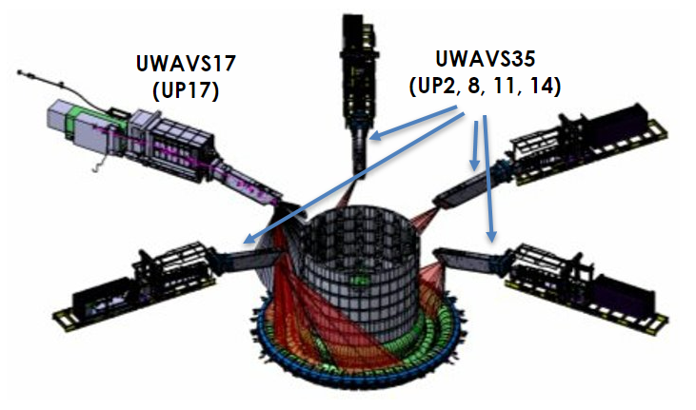

Figure 1. 55.GA ports around the tokamak

Typical UWAVS port with its subassemblies and some of the instrumentation is shown in   
Figure 2 below for better understanding of physical space I&C equipment occupies.

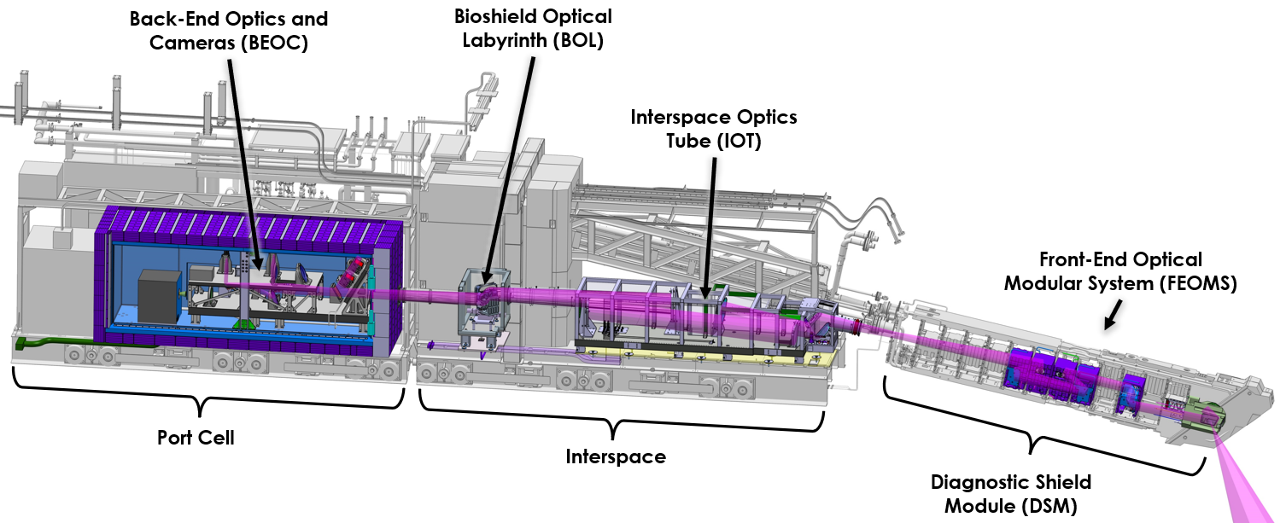

Figure 2. Illustration of a single 55.GA port

## UWAVS System Description

The UWAVS System is a key plasma diagnostic for ITER and is designed to provide real‑time view to the Divertor region (65% outer divertor, 60% of outer baffle, 15% of the inner baffle, and 45% of dome area) [22] in both IR (infra‑red) and Visible spectrum. UWAVS serves primary role in basic control, machine protection, and advanced control. Aside from this function UWAVS also serves ITER diagnostic by collecting and archiving critical information to be studied for physics measurements. UWAVS system uses two IR cameras, and 2 Visible cameras to provide 1‑color measurement and 2‑color measurement used by PCS (plasma control system). UWAVS measurements requirements, as defined in Annex B [22], are shown in Table 1.

The 55.GA (UWAVS) system is a large and complex diagnostic with a multitude of I&C (instrumentation and control) requirements. The system has most of the equipment located in BEOC (back‑end optics & cameras) and diagnostic hall. UWAVS also has several temperature sensors located throughout the beamline. An instrumentation diagram for UWAVS is shown in Figure 3. This is intended to provide a simplified overview. Fast controllers and slow controllers are in the diagnostic hall cubicles. The signals are routed via specially selected cables based on radiation and environmental exposure. There are thermocouples located throughout the beamline to provide temperature gradient and health of the optics.

Table 1. 55.GA Measurement Contributions

|  |  |  |  |  |  |  |  |  |  |  |
| --- | --- | --- | --- | --- | --- | --- | --- | --- | --- | --- |
| **DiagSyst** | **DiagRoleName** | **RoleName** | **MeasName** | **ParameterName** | **ConditionName** | **RangeValue** | **TimeFreq** | **SpatialWave** | **Accuracy** | **Meas Para Num** |
| **_Name** | **Resol** |
| 55.GA | Primary | 1a.1 MP | 16. Divertor operational | Max. surface |  | 200-400 °C 400-3600 °C | 10 ms | ‐ | 20% 10% | MP039 |
| parameters | temperature |
|  |  |  | 17. First wall (FW) | FW Surface | All heating ports, upper strike region, dome, |  |  |  | 30% |  |
| 55.GA | Primary | 1a.1 MP | visible image & wall temperature | luminance | baffle. > 50 % of rest, |  |  |  | absolute, 1% | MP042 |
|  |  |  |  |  | evenly distributed. | 40 ‐1E5 cd / m2 | 10 ms | 3 mm | relative |  |
|  |  |  |  |  |  |  |  |  |  |  |
| 55.GA | Primary | 1a.2 BC | 17. First wall (FW) visible image & wall | FW Surface | All heating ports, upper strike region, dome, | 200-400°C | 10 ms | 5 mm | 20°C 10°C | MP043 |
|  |  |  | temperature | temperature | baffle. > 50 % of rest, | 400-3600°C |  |  |  |  |
|  |  |  |  |  | evenly distributed. |  |  |  |  |  |
|  |  |  |  |  |  |  |  |  |  |  |
| 55.GA | Primary | 1b. AC | 38. Heat loading profile | Power load | Default | 0.1 ‐ 25 MW m‐2 | 0.5-10 ms | 3 mm | 10% | MP085 |
| in divertor |
| 55.GA | Primary | 2. PHY | 38. Heat loading profile | Power load | Disruption (fast window mode) | 0.02 ‐ 5 GW m‐2 | 0.5 ms | 3 mm | 20% | MP085 |
| in divertor |
| 55.GA | Primary | 1b. AC | 38. Heat loading profile | Surface | Fast-window | 1000 ‐ 3600 °C | 0.5 ms | 3 mm | 0.1 | MP086 |
| in divertor | temperature |
| 55.GA | Primary | 1b. AC | 38. Heat loading profile | Surface | Full-frame Fast-window | 200 ‐ 1000 °C | 10 ms 2 ms | 3 mm | 20% in 200-400°C 10% in 20% in 400-3600°C | MP086 |
| in divertor | temperature |
|  |  |  | 17. First wall (FW) visible image & wall | FW surface temperature | Full-frame mode |  | 10ms |  |  |  |
| 55.GA | Primary | 2. PHY | temperature | during ELMs, FW |  | 400 ‐ 3600°C |  | 5 mm | 20°C | MP044 |
|  |  |  |  |  | Fast-window mode |  | 2-10ms |  |  |  |
| 55.GA | Back Up | 1a.2 BC | 35. Impurity and D,T | GD, GT |  | 1E19 ‐ 1E25 at s‐1 | 1 ms | 50 mm | 30% | MP079 |
| influx in divertor |
| 55.GA | Back Up | 1a.1 MP | 35. Impurity and D,T | GBe, GC, GW |  | 1E17 ‐ 1E22 at s‐1 | 1 ms | 50 mm | 30% | MP078 |
| influx in divertor |
|  |  |  | 14. H‐mode, ELMs and L‐ H mode transition |  | Main/divertor plasma |  |  |  |  | MP030 |
| 55.GA | Back Up | 1a.1 MP | indicator | ELM Da bursts | Full-frame Fast-window | ‐ | 10 ms 0.5 ms | one site |
|  |  |  | 14. H‐mode, ELMs and L‐ H mode transition |  | Main/divertor plasma |  |  |  |  | MP033 |
| 55.GA | Back Up | 1a.2 BC | indicator | L‐H Da step | Full-frame Fast-window | 10 ms 0.5 ms | one site |
|  |  |  | 02. Plasma position and | Divertor channel |  |  |  |  |  |  |
| 55.GA | Supplementary | 1a.2 BC |  |  | Ip > 3 MA | ‐ | 10 ms | ‐ | 10 mm | MP002 |
|  |  |  | shape | location (r dir.) |  |  |  |  |  |  |
|  |  |  | 02. Plasma position and | Divertor channel |  |  |  |  |  |  |
| 55.GA | Supplementary | 1a.2 BC | shape | location (r dir.) | Ip quench | ‐ | 10 ms | ‐ | 20 mm | MP002 |
|  |  |  |  |  |  |  |  |  |  |  |
|  |  |  | 31. Escaping alphas and | First wall flux, |  |  |  | a/10 along poloidal |  |  |
| 55.GA | Supplementary | 1b. AC | fast ions | Non‐Alphas | Steady State | 0.2 ‐ 20 MW m‐2 | 0.5 - 10 ms | direction | 20% in 200-400°C 10% in 400-3600°C | MP072 |
|  |  |  |  |  |  |  |  |  |  |  |
|  |  |  | 31. Escaping alphas and | First wall flux, |  |  |  | a/10 along poloidal |  |  |
| 55.GA | Supplementary | 1b. AC | fast ions | Non‐Alphas | Transients | 0.2 ‐ 20 MW m‐2 | 0.5 - 10 ms | direction | 20% in 200-400°C 10% in 400-3600°C | MP072 |
|  |  |  |  |  |  |  |  |  |  |  |
|  |  |  | 31. Escaping alphas and | First wall flux, |  |  |  | a/10 along poloidal |  |  |
| 55.GA | Supplementary | 2. PHY |  |  | Steady State | 0.1 - 5 MeV | 0.5 - 10 ms | direction | 20% | MP071 |
|  |  |  | fast ions | Alphas |  |  |  |  |  |  |
|  |  |  | 31. Escaping alphas and | First wall flux, |  |  |  | a/10 along poloidal |  |  |
| 55.GA | Supplementary | 2. PHY |  |  | Transients | 0.1 - 5 MeV | 0.5 - 10 ms | direction | 20% | MP071 |
|  |  |  | fast ions | Alphas |  |  |  |  |  |  |
| 55.GA | Supplementary | 1a.1 MP | 12. Impurity species | Cu Influx | ‐ | 1E15 - 5E18 m-2.s-1 | 10 ms | integral | 10% | MP023 |
| monitoring |
| 55.GA | Supplementary | 1a.2 BC | 12. Impurity species | Extrinsic (Ne, Ar, | ‐ | 1E16 - 2E19 m-2.s-1 | 10 ms | integral | 10% | MP025 |
| monitoring | Kr) influx |
| 55.GA | Supplementary | 1a.1 MP | 12. Impurity species | W influx | ‐ | 1E14 - 5E17 m-2.s-1 | 10 ms | integral | 10% | MP027 |
| monitoring |

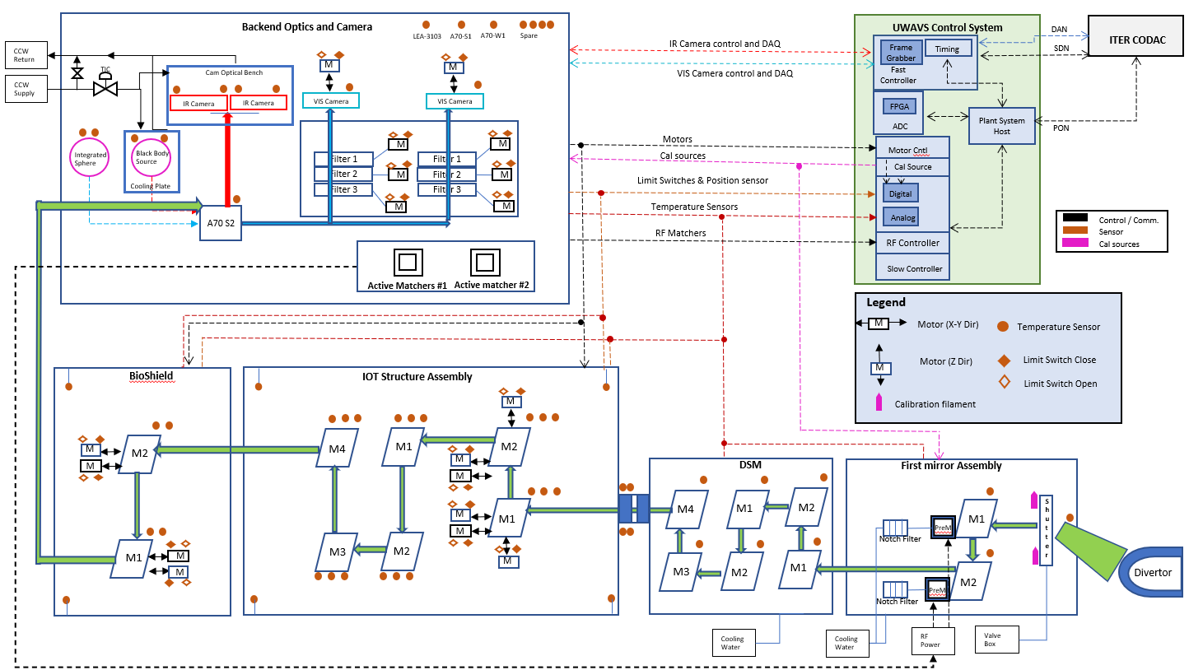

Figure 3. Illustration of the instrumentation and controls for 55.GA single port

The UWAVS components and their associated instrumentation are listed in Table 2. The components labeled SIC‑2 are monitored and controlled by ITER. All other instrumentation is monitored and controlled by UWAVS diagnostics.

Table 2. Regions, components, and associated instrumentation

| Region | UWAVS Component | UWAVS Instrument | QTY | Safety Class |
| --- | --- | --- | --- | --- |
| In vessel | A10 Mirror Module (Bullnose) | Thermocouple | 3 | ‑‑ |
| First Mirror assembly | 2 | ‑‑ |
| IR Cal source | 2 | ‑‑ |
| A20: Mirror Module #2 | Thermocouple | 2 | ‑‑ |
| A30: Mirror Module #4 | Thermocouple | 1 | ‑‑ |
| A30: Mirror Module #5 | Thermocouple | 1 | ‑‑ |
| A30: Mirror Module #6 | Thermocouple | 1 | ‑‑ |
| A30: Mirror Module #7 | Thermocouple | 1 | ‑‑ |
| Interspace | Closure Plate Window | Thermocouple | 4 | ‑‑ |
| IOT Structure | Thermocouple | 4 | ‑‑ |
| A40 | Motor | 5 | ‑‑ |
| Limit Switch | 10 | ‑‑ |
| Thermocouple | 6 | ‑‑ |
| A50 | Thermocouple | 12 | ‑‑ |
| Bioshield Plug | BOL | Thermocouple | 2 | ‑‑ |
| A60 | Motor | 4 | ‑‑ |
| Limit Switch | 8 | ‑‑ |
| Thermocouple | 4 | ‑‑ |
| Port Cell | Valve Box | Limit Switch | 10 | ‑‑ |
| Limit Switch | 16 | SIC‑2 |
| Electromagnetic Solenoid | 5 |  |
| Electromagnetic Solenoid | 2 | SIC‑2 |
| Pressure sensor | 2 | ‑‑ |
| Shutter Actuation Pump | 2 | ‑‑ |
| BEOC | Thermocouple | 4 | ‑‑ |
| RF Matching Box | 2 | ‑‑ |
| BEOC: Filter Wheel Assembly | Limit Switch | 16 | ‑‑ |
| Filter Wheel Motor | 6 | ‑‑ |
| Vis Camera | 2 | ‑‑ |
| Linear Stage Motor | 2 | ‑‑ |
| BEOC: Calibration Assembly | Thermocouple | 5 | ‑‑ |
| Blackbody Source | 1 | ‑‑ |
| Integrating Sphere | 1 | ‑‑ |
| BEOC: Optical Bench | Thermocouple | 4 | ‑‑ |
| IR Camera | 2 | ‑‑ |
| Diagnostic Hall | Cubicle Area | Cubicle | 2 | ‑‑ |
| RF generator | 2 | ‑‑ |
| Fast controller | 3 | ‑‑ |
| PLC | 3 | ‑‑ |
| Motor Controller | 1 | ‑‑ |
| DC power supply | 6 | ‑‑ |
| signal conditioning unit | 1 | ‑‑ |
| Blackbody controller | 1 | ‑‑ |
| mTCA chassis | 1 | ‑‑ |
| Master controller CPU | 1 | ‑‑ |
| PSH | 1 | ‑‑ |

# High‑Level Hardware Architecture

The UWAVS Instrumentation and Control system has two hierarchical roles. At the higher level the UWAVS I&C system is required to serve the larger needs of the ITER plant system. As with other diagnostics, the UWAVS system will serve as an integrated node in the CODAC (Control, Data Access and Communication) network system as a designated ITER Plant System.

At the lower level the system is required to attend to the local needs of the UWAVS electro‑mechanical and opto‑electrical systems. This includes measurement, control, monitoring, calibration, and maintenance using various instruments to perform UWAVS operations such as active alignment, mirror cleaning etc.

Each UWAVS port has independent two full sized cubicles. One full size cubicle houses fast controller with mTCA chassis and frame grabbers for high‑speed, high‑performance measurement, as well as the supervisory fast controller. Second full‑size cubicle contains slow controller and all the controllers for COTS (Commercial Off The Shelf) devices except for cameras. Slow controller is used to perform slow, low frequency I&C functions. Port 02 and   
Port 17 differ from other ports in terms of cubicle layout. The differences are detailed in   
Section 4.1 of this document. Detailed cubicle Bill of Material (BOM) or each port is available in Section 4.7 of this document.

# Independent UWAVS POrt Control System (Port 02, 08, 11, 14,17)

## Control System Architecture

All UWAVS ports are identical to each other in terms of instrumentation, fast controllers, slow controllers, and COTS controllers. The functional architecture of UWAVS for a single port is shown in Figure 4. Several junction boxes are used to route the signal carrying cables from port plug to the diagnostic hall. Due to Electric Feed Through (EFT) located by port plug, limited number of connections for instrumentation in bullnose are available. This, along with challenging environmental conditions due to radiation exposure and temperature has greatly influenced the instrument selection. The shutter located in the port plug is operated using valves box in port cell using pneumatic tubes.

IR cameras and Visible cameras are key detectors in UWAVS diagnostics located in BEOC. Both IR and Visible cameras are regularly calibrated using blackbody source, and integrated sphere respectively, which are also located in BEOC. IR cameras and blackbody source are cooled separately using cooling water supply to keep them functioning at rated temperatures for optimal measurement performance. Several of the optics in BEOC are fitted with thermocouples to monitor temperature effects. Each visible camera is mounted on linear stage motor to perform some of the calibration procedures.

Diagnostic hall houses fast controllers, slow controllers, COTS devices, master controller, network switches, and Plant System Host (PSH). Signals from different parts of the UWAVS port, DSM (diagnostic shield module), IOT (Interspace Optical Tube System), BOL (Bio‑shield Optical Labyrinth), BEOC are routed to the diagnostic hall where controllers run I&C algorithms and software to perform measurement, control, and monitoring functions. The detailed hardware architecture laid out in [23].

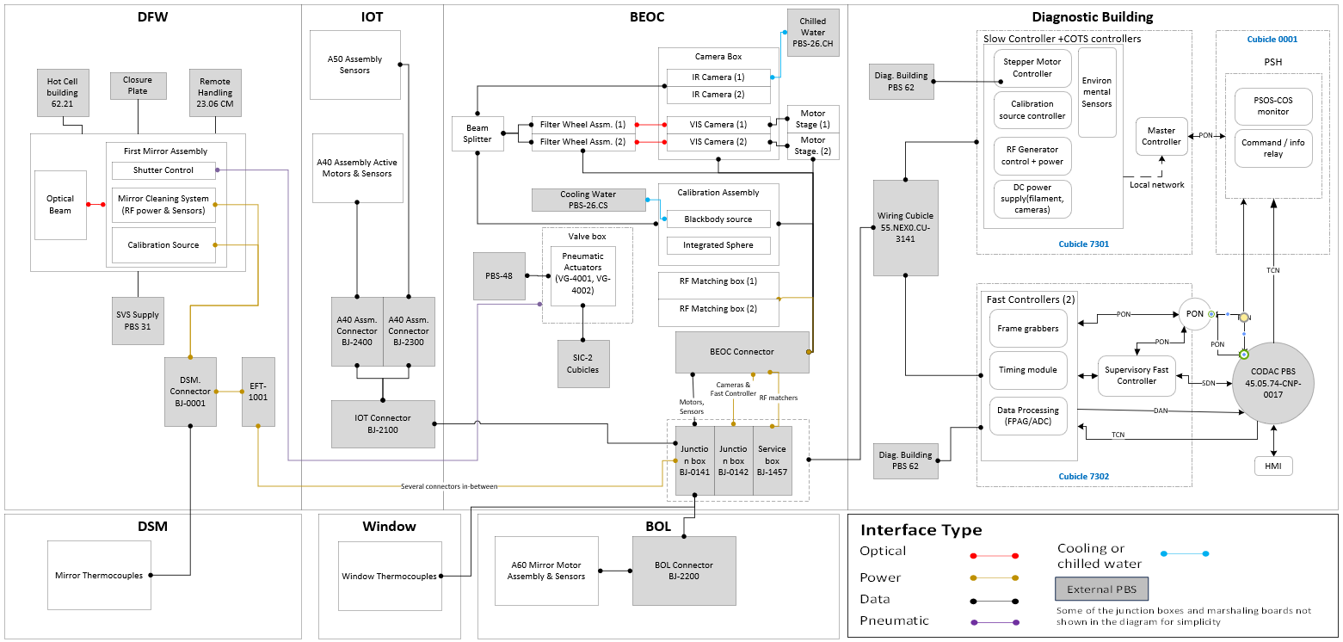

Figure 4. Top level architecture representative of port 14

### DFW

This region contains A10 assembly that has mirror cleaning assembly, shutter system, transmission monitoring source used for transmission monitoring, and thermocouple on the aperture. The mirror cleaning assembly requires RF (Radio Frequency) power delivered to clean the mirrors via tuning stub attached to each mirror. The power carrying cables are chosen to be compatible with RF and radiation exposure requirements. The shutter is actuated using valve box located in the port cell using pneumatic tubes routed from port cell to the shutter within bullnose. Power for calibration source is routed from diagnostic hall to the bullnose as well. All the cables are eventually routed through the EFT.

### DSM

This region houses several mirrors in A20 module and A30 module. The mirrors are outfitted with thermocouples that are routed to the slow controller in diagnostic hall.

### (IOT)

This region has A40 assembly and A50 Assembly. A40 assembly are the components in the IOT associated with the active alignment system, including the stepper motors, limit switches, and thermocouples. The signals for these components are routed to the control cubicle CU‑7302   
(port 14) through cable trays. A50 assembly mirrors are thermocouples.

The A40 mirrors within the IOT are mounted on the stepper motors and use limit switches for homing and troubleshooting. UWAVS I&C also sends high wattage power to instruments located in DSM and BEOC as represented by color orange. Stepper motors, limit switches, and thermocouples are routed via cable trays, junction boxes, and connectors to the diagnostic hall.

### Bioshield (BOL)

This region houses two large mirrors in A60 module. Each mirror is controlled by 2 stepper motors to allow occasional alignment adjustment during maintenance periods. The Signals are routed through cable trays to the diagnostic hall.

### (BEOC)

BEOC region contains several instruments and equipment. Notably, it has two IR cameras, and two visible cameras crucial to UWAVS measurements. The power supplies to all the cameras are routed through diagnostic hall to the BEOC, and are regularly calibrated using blackbody source, and integrated sphere respectively, which are also located in BEOC and controlled by equipment in diagnostic hall. IR cameras and blackbody source are cooled separately using cooling water supply to keep them functioning at rated temperatures for optimal measurement performance. Several of the optics in BEOC are fitted with thermocouples to monitor temperature effects. Each visible camera is mounted on linear stage motor to perform some of the calibration procedures.

RF Active matchers are tuned by controller in diagnostic halls and receive RF power from RF generators in diagnostic hall. RF matching units dissipate large power. The details of power requirements and dissipation are in Section 4.2. There are two filter wheel assemblies, each having three filter wheels and stepper motors for filter selection. Several of the optics are outfitted with thermocouples. The detailed instrumentation in BEOC is shown in Figure 5.

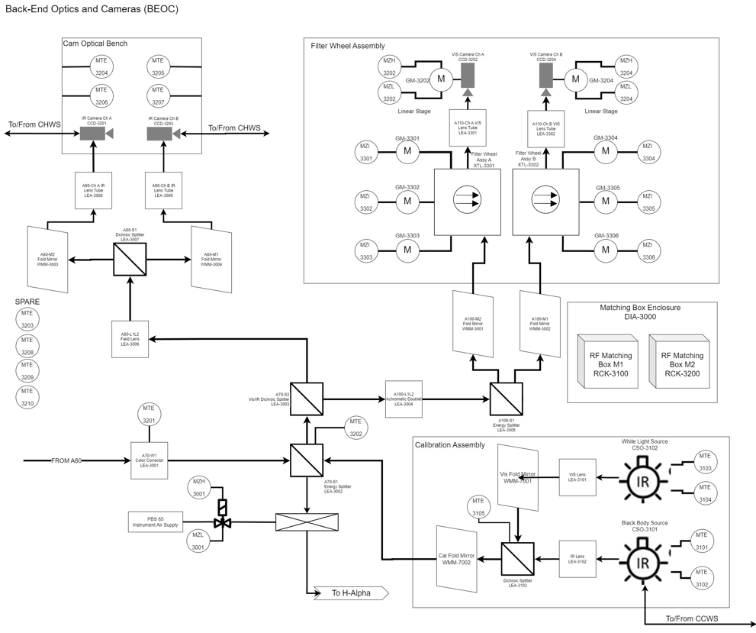

Figure 5. BEOC instrumentation and BEOC calibration sources location

### Gallery

This region has north‑east shielded corner that also houses the cubicles. The motor controllers, and camera power supplies for Port 02 and Port 17 are co‑located in the cubicle in the north‑east shielded corner. The two ports would be sharing this cubicle with other diagnostics such as NEX0. Please refer to cubicle layout in Section 4.1 for more details.

### Cubicles in Diagnostic Hall

There are two full sized cubicles assigned to each UWAVS port with primary control function and gateway to the CODAC networks. The cubicle 7302 contains the Fast Controller with mTCA chassis, frame grabbers plus modules for the high‑performance measurement and data acquisition. There is also a supervisory fast controller which serves as the supervisor for control system through communications with the PSH over the Plant Operations Network (PON).

The cubicle 7301 houses the slow controller, master controller, and all other COTS controllers such as motors drivers, controllers for calibration devices, RF generator, and power supplies.

The fast controller requires all four ITER network interfaces (PON, DAN, SDN, and TCN). The controller is linked to the mTCA chassis using the Multisystem Extension Interface (MXI) hardware described in the PCDH. The real‑time measurement to the SDN and the data streaming to the DAN are accomplished using this system.

Valve box that actuates the shutters is located in port cell. Valve box contains pneumatic actuators and pumps that are routed to the shutter for pneumatic actuation. Shutter control system is elaborated in Section 3.5.

## UWAVS Port Subsystem Design

Each of the UWAVS port is divided into six subsystems based on the control strategy and associated mechanical components. There is some overlap of components and functionality of these subsystems. The subsystems are further broken down into sections that show control functions and instrumentation associated with it. Typical UWAVS port with its subsystem is shown in Figure 6.

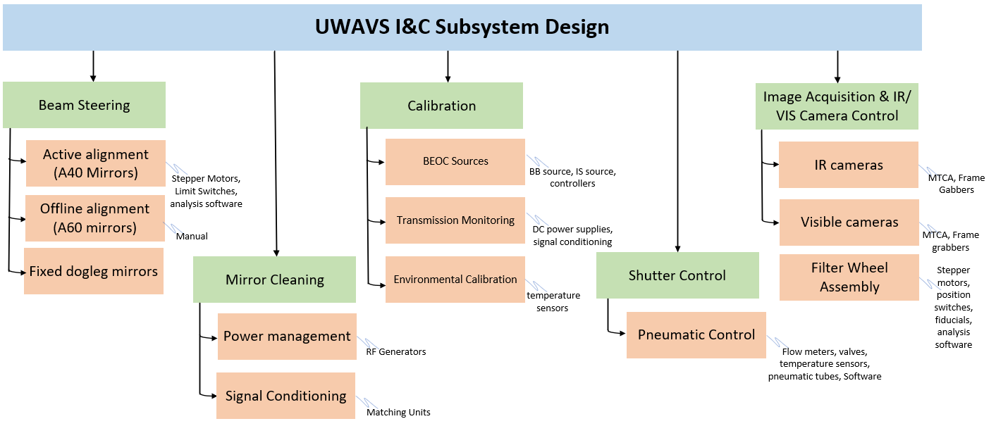

Figure 6. 55.GA design breakdown into sub systems.

**Beam Steering Sub System** – The beam steering subsystem is comprised of active and passive components. The beam from tokamak is steered to the cameras located in BEOC via combination of fixed dogleg mirrors, and motor‑controlled mirrors in A40 assembly and A60 assembly. The mirrors in A60 assembly are aligned only occasionally (as needed basis) during maintenance period, via operator visual/manual input. Mirrors in A40 assembly are used to perform active alignment during normal operations and are controlled using motors, drivers, and software algorithms. This process is described in following Section 3.2.1.

### Active Alignment

55.GA performance is dependent on the accuracy and range of the field of view. Active alignment is designed to compensate the thermal displacement between the vacuum vessel and tokamak building and is achieved by instrumenting and controlling the A40 mirrors in IOT subsystem located in the interspace. Beam is steered from vacuum vessel to the cameras located in the port cell using the combination of motorized mirrors, and dogleg mirrors. Detailed mechanical description is provided in [19].

All the instrumentation for active alignment is controlled and monitored by UWAVS slow controller located in the diagnostic hall cubicle CU‑7302. There are no external interfaces for this subsystem.

**Special Design Considerations** ‑ The stepper motors, signal carrying cables, temperature sensors placed in interspace and port cell are subject to very high temperatures and radiation exposure. Therefore, all instrumentation in interspace needs to be radiation hardened and to ITER specifications for the instrumentation materials. A40 mirrors compensate for vessel deformation by using 2 rotational actuators on A40‑M1 mirror and 2 rotational actuators and piston on A40‑M2 mirror. Combined these actuators allow control of position, pointing, and focus. In addition, each visible camera is mounted on linear stage to compensate difference between visible and IR camera images. Images captured on visible and IR cameras during alignment along with a tokamak model are used to provide feedback to the A40 mirror motors. Please refer to UWAVS optical model results for detailed alignment plan [24].

#### Control Strategy & Operational Scenarios

Initial positions of the A40 motors at various temperatures are recorded at the time of FQT (Factory Qualification Test), and System Commissioning Test by manually aligning the imaging system to known object fiducials in the inv‑vessel imaging plane. This look‑up table of [motor positions, VV Temp] is used as a reference for active alignment during normal plasma operations. Different temperatures at which this procedure is done are shown in Table 3

Table 3. Stepper Motor ‘Pre‑Set’ Positions Based on Temperature

|  |  |  |
| --- | --- | --- |
| Pre‑Set' Positions for Motors | Temperature | Structure Associated with temperature |
| A40‑M1‑Motor‑1‑Pos | 20 Deg C | IOT, Port Cell |
| A40‑M1‑Motor‑2‑Pos |
| A40‑M2‑Motor‑1‑Pos |
| A40‑M2‑Motor‑2‑Pos |
| A40‑M2‑Motor‑2‑Pos |
| A40‑M1‑Motor‑1‑Pos | 52 Deg C | IOT, Port Cell |
| A40‑M1‑Motor‑2‑Pos |
| A40‑M2‑Motor‑1‑Pos |
| A40‑M2‑Motor‑2‑Pos |
| A40‑M2‑Motor‑2‑Pos |
| VIS‑1‑Linear Stage‑Pos | 20 Deg C | BEOC |
| VIS‑2‑Linear Stage‑Pos |

**Normal Operations ‑** During normal plasma operations, the A40 mirrors are commanded to ‘Pre‑Set’ positions based on the temperature of IOT and Port Cell. In the Fast Controller, IR cameras and Visible cameras capture images at ‘Pre‑Set’ positions to determine current view of the Tokamak matches expected view based on tokamak model and pixel‑to‑wall mapping calibration. If there is a matching error, a software algorithm is used to find new A40 mirror assembly position to correct the optical alignment.

Fast controllers and frame grabbers housed in cubicle‑7302 in diagnostic hall use captured images and the reference tokamak model to calculate the ‘offset’ that predicts how much A40 mirror motors would need to be adjusted to achieve good alignment. This ‘Corrected Offset’ is communicated to ‘Motor Controller’ over PON network. The motor controllers command the stepper motors on A40 M1 and A40 M2 mirrors over radiation hardened cables. This feedback loop with images captured on IR and Visible cameras is used to actively control A40 mirror assembly to maintain an optimal alignment.

As the temperature of vessel changes during bake out and plasma operation, A40 mirrors can maintain the alignment by using the feedback loop with images captured on cameras. If the active alignment fails and images captured are not correct representation to tokamak surface locations, A40 mirrors are commanded to ‘Pre‑Set’ position based on the present temperature of the vessel. After software algorithms confirm the optimal alignment at ‘Pre‑Set’ positions, active alignment is resumed.

The active alignment is a low frequency alignment. The signal chain for active alignment is shown in Figure 7.

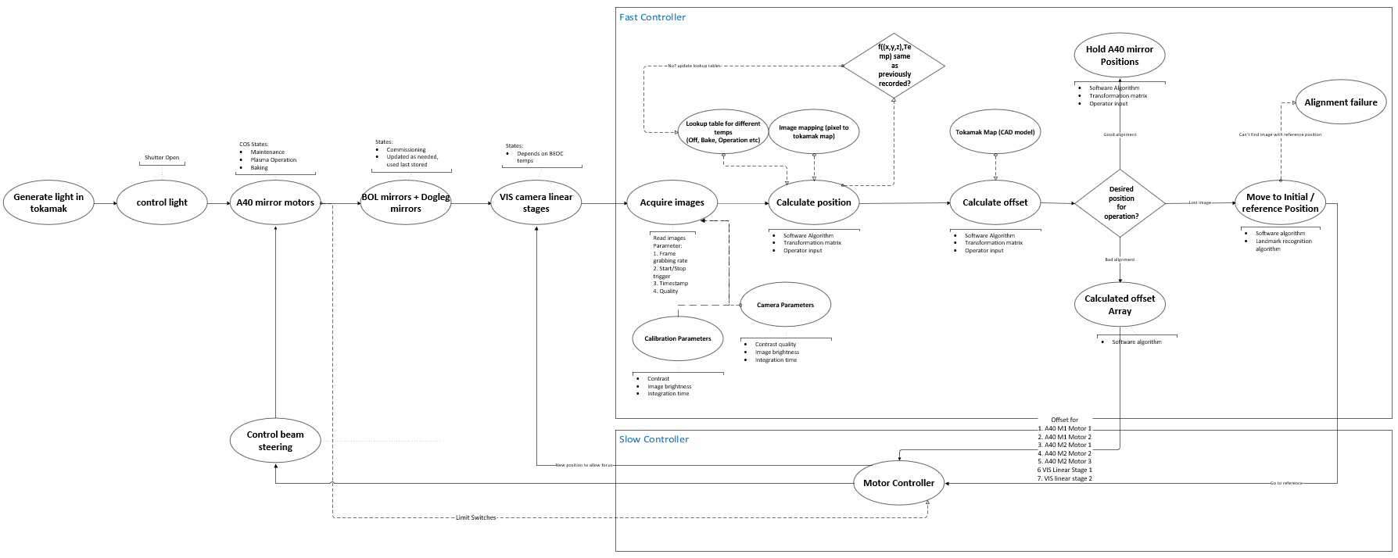

Figure 7. Active alignment signal chain

### Active Alignment Components

The basic components of active alignment are shown in Figure 8. Portion (a) shows stepper motors mounted on the A40 mirrors M1 and M2. Each stepper motor has 2 limit switches for position sensing. The stepper motors are controlled using the motor drivers located in the diagnostic hall. The limit switches are monitored using slow controller. Portion (b) shows that mirror M2 has three stepper motors, and mirror M1 has two stepper motors. Together M1 and M1 provide five degrees of freedom to perform active alignment. The mirrors M1 and M2 are outfitted with 3 thermocouples each to measure the temperature gradient across the mirror to understand mirror deformation. A single motor controller will be used per port to control the A40 mirror motors. The motor controller can micro‑step the stepper motors if needed.

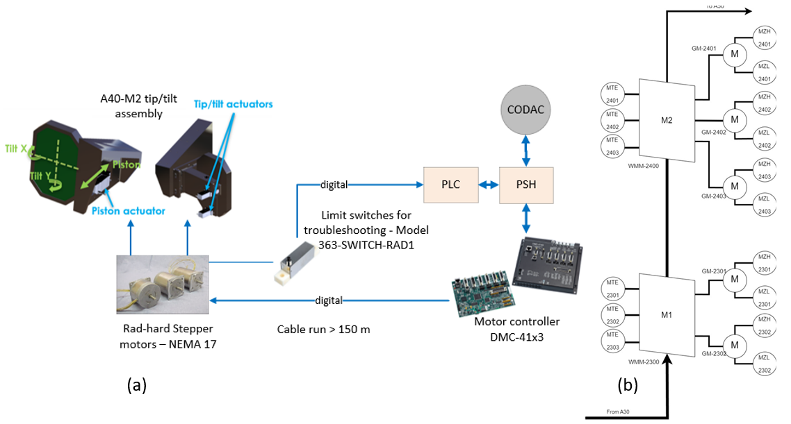

Figure 8. Active alignment system (a) Components (b) detailed instrumentation on A40 mirrors

The mechanical design with steppers mounted on mirror is shown in Figure 9.

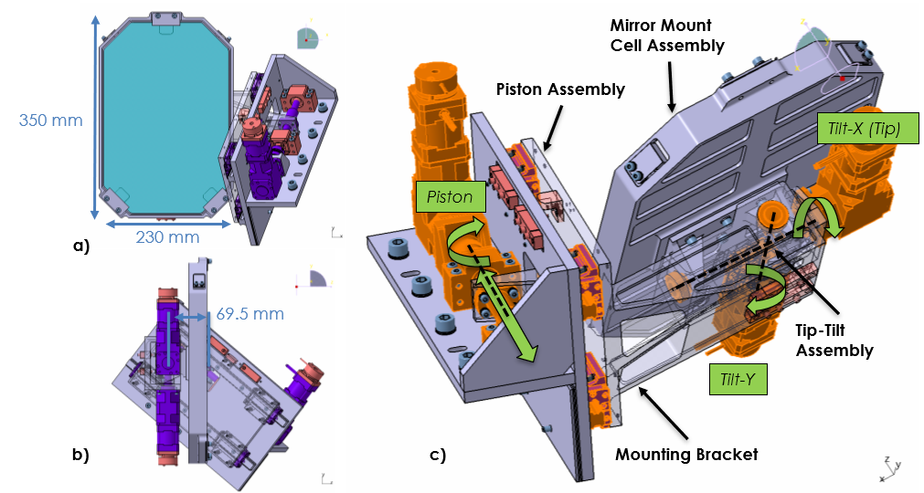

Figure 9. A40‑M2 mirror subassembly physical architecture. Mirror (a) normal, (b) side, and   
(c) rear isometric views. Some components transparent for clarity.

### Stepper Motors

Standard NEMA‑17 size stepper motors will be used throughout the UWAVS system. Where needed, radiation‑tolerant stepper motors from Empire Magnetics will be used (model RH‑U15‑2).

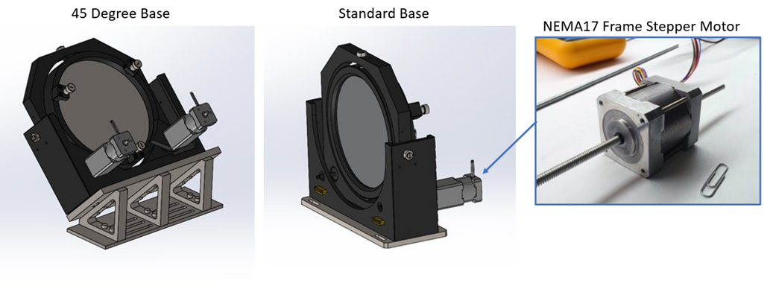

Figure 10. Photos of a typical UWAVS mirror mount and radiation‑hardened stepper motor.

The stepper motors have the advantage that they can be reliably operated in open‑loop, an important requirement as it avoids the need for radiation‑sensitive encoder electronics.

Note: It has yet to be confirmed that the stepper motors can be used in the interspace due to the high magnetic fields. This is under investigation and will be resolved during FDR.

### Rad‑hard Limit Switches

The mechanical design calls for each mirror axis having limit switches to serve as a home reference and end of travel detection. Radiation hardened limit switches will be used on mechanical stages in the Port Cell. A candidate switch is ALLECTRA 363‑SWITCH‑RAD1 that is used on multiple ITER diagnostic designs, including 55.G1.

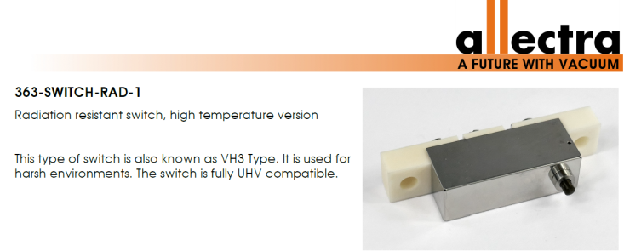

Figure 11. Photos of a typical UWAVS mirror mount and radiation‑hardened stepper motor.

Two potential miniature switch candidates are from Crouzet are shown below. These will be pursued during final design.

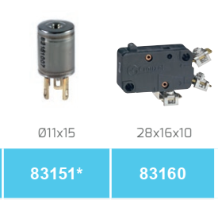

Figure 12. Rad‑resistant miniature limit switch from Crouzet

Note: The limit switches are useful for moving the mirrors to repeatable positions. However, in practice all adjustments will be relative after initial alignment during system commissioning. Therefore, the limit switches can be considered useful but non‑essential in failure.

### Stepper Motor Controller/Driver

The step motors will be controlled and driven using modular system from Physik Insrumente PI 885 R2 chassis equipped with a PI 888.M1 Processor module and twenty model C­­663.12C885 Mercury Step Stepper Motor Controller Modules. The chassis will be powered using an external 24V power supply.

This controller has several benefits including native Experimental Physics and Industrial Control System (EPICS) support and the fact that it is also being adopted by the 55.G1 system. This system is considered COTS requiring integration discussed in Section 3.7

One issue that needs to be tested is the ability of the driver cards to drive the step motors over 100m or more of cable.



Figure 13. Stepper Motor Control system components from Physik Instrumente

Table 4. Active Alignment I&C Components per Port

|  |  |  |
| --- | --- | --- |
| Device | Manufacturer Number/  ITER Part Number | QTY |
| Rad‑hard Stepper Motors | Model RH‑U17‑2 | 5 |
| Rad‑hard Limit Switches | Model 363‑SWITCH‑RAD1 | 10 |
| 3U Motor Controller Chassis | PI C885.RD | 1 |
| Motor Controller Card | PI C‑663.12C885 | 5 |
| Modular DC Power Supply Chassis | Keysight N6700 Controller | 1 |
| DC Power Supply Module | Keysight N6700 Module | 1 |

## Calibration Strategy

This section deals with the I&C instrumentation and approach for the calibration strategy for 55.GA in the visible and infrared range. Initial calibration of the BEOC is done during Factory Qualification Testing, final calibration is done after installation as the final step of commissioning, see UWAVS Calibration Plan [25] for a detailed description. Many calibration values and parameters are noted during this to applied in overall calibration of IR cameras and Visible cameras during normal plasma operations. For robust system response, in‑situ calibration is necessary to compensate for deteriorating optics and instrument response. Changes in the response of the instrument during operation include overall transmission due to mirror degradation, camera sensitivity, camera, and optics temperature changes.

The main goal of calibration is to convert the raw signal from the output of the detector to measurable quantity using corrections for different effects occurring in the system. Some of the requirements and complexity for IR calibration and Visible calibration differ in some respects. IR calibration is more sensitive to transmission in optical line, emissivity of the surface, and detector and optics response.

This section has a brief description of the calibration procedure and the instrumentation or signal conditioning used for that particular calibration. The 55.GA calibration approach is supported by implementing four different types of verifications,

* Front to end calibration
* Transmission Monitoring
* Back‑end calibration
* Verification of algorithms and external data

Overall calibration, requirements, and performance measurement is topic for optical system engineering and hence scientific details and rationalization of each calibration method required by [25]. Step‑by‑step I&C process flow for calibration methods are shown in [23]. Different types of calibration that I&C will be participating in are shown in the Table 5.

Table 5. I&C Summary of IR and VIS Calibration

|  | Calibration Means | | | |  |
| --- | --- | --- | --- | --- | --- |
| IR Camera | VIS camera | Algorithms/ Software | Model |
| Calibration |  |  |  |  | COTS device |
| Camera calibration using internal camera shutter | X | X |  |  | IR camera, VIS camera, Fast controllers |
| Calibration using BEOC source | X | X |  |  | Blackbody source controller, Integrated sphere controller |
| Transmission monitoring | X | X |  |  | DC Power Supply, filament |
| Image mapping |  | X | X | X |  |
| Temperature conversion | X |  | X | X |  |
| Emissivity map | X |  | X | X |  |
| Spectral Correction |  | X | X |  |  |

Overview of calibration for UWAVS is shown in Figure 14 below. It shows, there are many types of calibration procedures and parameters applied after the raw image is captured by IR cameras and visible cameras located in the BEOC. The IR and Visible cameras are configured (integration time, filter wheel positions, etc.) for required measurement at the beginning of calibration process. The corrections related to detector and light are types of calibrations performed on regular basis during short term maintenance and updated in software. There are calibration procedures performed during factory acceptance test such as back end calibration that gives calibration values for flat field and spectral correction, detector data processing, and background subtraction. Other procedures such as transmission monitoring are performed in‑situ regularly to determine loss of light caused in transmission line due to wear and tear of optics because of normal operations.

Temperature conversion, image mapping are calibration related to converting radiation or pixel to a measurable quantity required by UWAVS diagnostics. These calibrations involve software algorithms, look‑up tables, and 3D tokamak model.

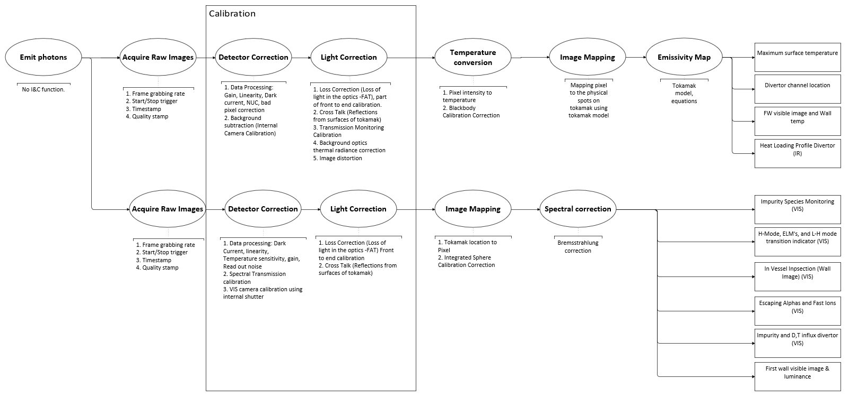

Figure 14. Different types of Calibrations during UWAVS measurement.

### Camera Calibration

IR cameras and Visible cameras are calibrated at end of normal operations during short term maintenance period (STM). Operator will use calibration procedures to capture NUC, and dark current values and update them in the 55.GA software and CODAC configurations using PON network. A detailed I&C flow for calibration procedure is provided in [23].

### Calibration Using BEOC Sources

Camera images require to establish the relationship between digital output of the camera and temperature or luminance. This is achieved by using calibration sources, blackbody source for IR camera and integration sphere with white light source for visible camera. The calibration sources are physically located in BEOC structure, providing the nomenclature BEOC calibration sources.

Blackbody source is configured using oven controller which provides different set point temperatures. Radiation emitted by blackbody at different set points is captured by IR cameras for different integration times. This gives a lookup table values for each integration time.

Each visible camera has a set of filter wheels. Integrated sphere with white light source is used in similar manner to perform calibration process and obtain look‑up tables for luminance for each integration time using the visible cameras. This process repeated for different filters. Detailed I&C operation procedures for these calibrations are provided in [23]. Detailed filter wheel assembly is described in Section 3.6.7.

It takes ~ 80 mins for blackbody source to warm up and reach stable temperature. Integrated sphere takes ~ 5 mins to reach reference luminance. Calibration using BEOC sources is thought be done minimum once a year, with ability to perform it during short term maintenance (STM) if needed.

The Figure 15 shows physical location of blackbody source and integrated sphere in BEOC with respect to IR camera and visible camera.

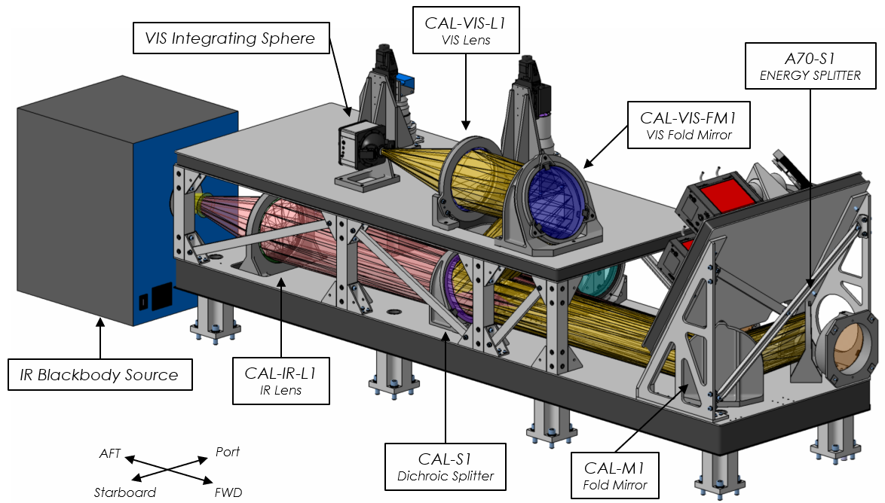

Figure 15. BEOC calibration source location with respect to cameras

#### BEOC Sources & Components

The BEOC contains two light sources: A Blackbody source for the IR cameras and white LED based fixed luminance sphere for the visible cameras.

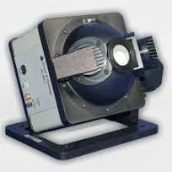

Figure 16. Picture of the Model 458‑4 LED‑Standard Lamp with Integrating Sphere

The luminance sphere selected is an Optronics Laboratories model OL 458‑4 NIST‑traceable source shown in Figure 16. The OL 458‑4 consists of an optics head and an external power supply. Internal to the head is the OL 458‑4 has an integrated constant current supply to provide luminance stability. The head will be simply controlled by powering the device from a switchable 48VDC power supply in the diagnostic hall. While the head provides a USB interface for optional remote control, this feature will be disabled, and any associated electronics removed.

The blackbody source is a more complicated device as it utilizes a high‑temperature furnace that must be precisely temperature regulated. The source selected is an Advanced Energy model M330 (Figure 17) with some customization and modification including separating some electronics and re‑packaging the furnace.



Figure 17. Model M330 Blackbody Source (shown without customization)

There are several advantages to re‑packaging the device. First, the unit is built into a standard 19” rack enclosure that is not suitable for the ITER Port Cell environment and is awkward to integrate into the BEOC. Fortunately, the modular construction of the unit facilitates separation of the furnace assembly, power transformer, and controller for better hardening (Figure 18). Second, the controller is a standard COTS Eurotherm temperature controller that will be remotely located in the diagnostic hall by using a thermocouple transmitter recommended by the vendor (Advanced Energy).

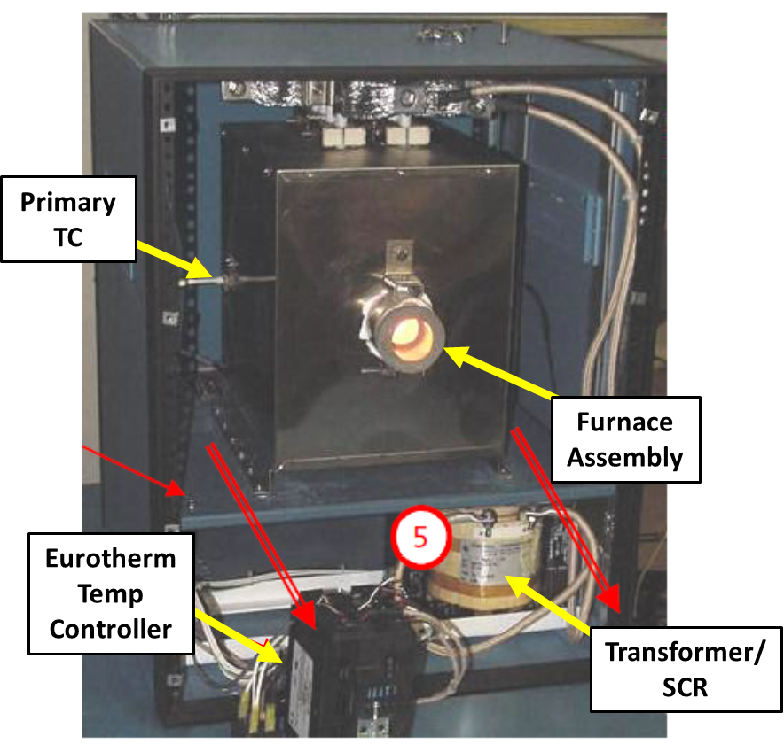

Figure 18. Inside of the enclosed Model M330 Blackbody Source. The internal assemblies will be removed from the enclosure for integration directly in the BEOC. The controller will be located in the diagnostic hall.

#### BEOC Sources BOM

The I&C components used for the BEOC calibration are listed in Table 6 below. Note that the Keysight Modular DC Power supply is shared with other systems.

Table 6. BEOC Calibration BOM

| Device | Manufacturer Number/ ITER Part Number |
| --- | --- |
| Black Body Source | Advanced Energy M330 |
| Visible Source | Optronics Laboratories OL 458‑4 |
| Modular DC Power Supply Chassis | Keysight N6700 Controller |
| DC Power Supply Modules | Keysight N6700 Modules |

### Transmission Monitoring

Transmission monitoring is used in 55.GA to assess the loss of light in optics due to wear and tear of optical components and general aging of the 55.GA system. Transmission changes in IR and Visible spectrum over lifetime of 55.GA include mirror coating degradation and deposition of foreign objects or debris on the first mirrors. This impacts the accuracy of measurement done by detectors (IR and VIS cameras) because less light is reaching the cameras causing inaccurate surface temperature measurement by IR cameras. Therefore, it is important to perform a procedure for monitoring and correcting the transmission change. For this purpose, 55.GA uses a filament attached to a shutter in bullnose as a transmission monitoring source. The filament can be heated from range of 400 deg c to 1500 deg c allowing both IR cameras (~400 deg c range) and Visible cameras (~1500 deg c) to monitor transmission changes in their respective bands.

To perform Transmission Monitoring, a shutter is closed, and DC power is sent to the heated filament located on the shutter. Voltage received at heated filament is read to calculate power deposited and calculate referred temperature of the filament. After the filament is heated to a certain temperature set point and is stable, IR cameras and Visible cameras acquire images. This process is repeated for defined set of integration times and gains.

The images acquired by IR and Visible cameras are compared to the previous data to calculate the ‘delta’ image that shows degradation in transmission of light since last transmission monitoring was performed. Mirror temperatures and other optics temperatures in 55.GA system are acquired during the process and need to be used as calibration factor for the images. The ‘delta’ images are used to calculate the transmission monitoring co‑efficient and is updated in the 55.GA system and CODAC via PON network. All the images captured during transmission monitoring procedure, including ‘delta’ images are streamed on DAN network to CODAC. Detailed I&C flow is documented in [23].

Transmission monitoring is performed at the end of every normal plasma operation (as needed) and during the short‑term maintenance (STM).

#### Transmission Monitoring Components

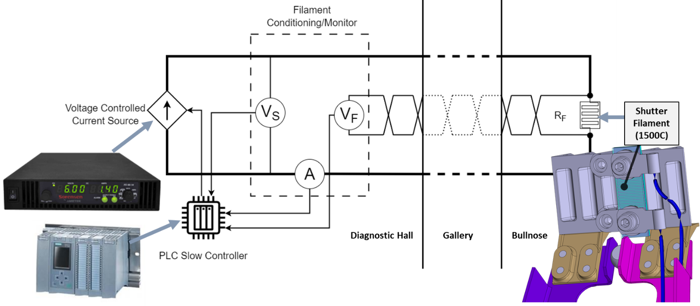

Figure 19. Transmission monitoring filament control scheme

The UWAVS system uses a heated source mounted on the shutter (in the bullnose) to monitor changes in optical transmission and provide correction factors. The heater is a single assembly containing two filaments. Each of the two filaments is driven and measured using separate circuits. The transmission monitoring process relies on accurate measurement of the electrical power delivered to the filament which in turn depends on the current through the filament *IF* and the voltage across the filament *VF:*

**Power = IFVF**

The filaments are driven using a programmable DC power supply remotely located in the diagnostic hall cubicle, so large voltage drops are expected due the high current (10‑20A) and long wires (around 100m). Therefore, a Kelvin‑type 4‑wire measurement scheme is used to drive a precise current while accurately measuring the voltage across the filament.

A diagram is of the measurement is shown in Figure 19. One pair of wires is used to drive a precise current through the filament. A second pair of wires (carrying no current) is used to measure the potential difference across the filament. A 16‑bit Analog Input (AI) channel on the PLC (programmable slow controller) slow controller is used to monitor the voltage with sufficient precision. The signals are filtered using a custom module to remove noise including potential Radio Frequency (RF) pick‑up.

The exact current, voltage, and power will depend on filament construction which are currently in development. Anticipated range for power is 75‑100W, with currents ranging from 10‑20A and voltage between 5 and 15V. Estimated precision in power measurement is 0.14% based on experience.

In order to use absorbed electrical power for calibration it is important to understand potential changes in filament emissivity with age. Prototyping and testing are essential to validate technique and is planned during final design.

#### Transmission Monitoring BOM

The I&C components used for the transmission monitoring are listed in Table 7 below. Note that the Keysight Modular DC Power supply is shared with other systems, and the Siemens PLC listed is the Plant System Slow Controller.

Table 7. Transmission Monitoring BOM

| Device | Manufacturer Number/ ITER Part Number |
| --- | --- |
| Filament | Under design |
| PLC Slow Controller | SM531‑8AI /  6ES7531‑7KF00‑0AB0 |
| PLC 8 Analog Inputs Module | SM531‑8AI /  6ES7531‑7KF00‑0AB0 |
| Signal Conditioning Module | Under Design |
| Modular DC Power Supply Chassis | Keysight N6700 Controller |
| DC Power Supply Modules | Keysight N6700 Modules |

### Environmental Monitoring

55.GA has thermocouples mounted on mirrors, several optics, and structures throughout the beamline. The detailed distribution is shown in Figure 3. The A10 assembly, DSM, IOT, BOL, BEOC structures, and mirrors located in them are subject to high temperatures during the normal plasma operations.

Thermocouples on mirrors and optics are used in IR calibration procedures to compensate for changing focus, imaging shift, and self‑emission due to higher temperatures. Multiple thermocouples are used in structures DSM and IOT to understand temperature gradient and provide redundancy. The UWAVS system uses N‑Type thermocouples specified by ITER.   
A specific part number has not yet been provided. For reference the mechanical designers have been using an N‑Type thermocouple in a 316L SST Housing from Omega.

#### Environmental Monitoring BOM

Table 8. Thermal Calibration BOM

| Device | Manufacturer Number/ ITER Part Number |
| --- | --- |
| PLC Slow controller | 6ES7516‑3AN01‑0AB0 |
| 8 Chan Analog Inputs Module U/I/RTD/TC (qty 2) | SM531‑8AI/ 6ES7531‑7KF00‑0AB0 |
| N‑Type Thermocouples | TBD |

## Mirror Cleaning System

The 55.GA system has first mirror assembly containing A10 mirror group and associated instrumentation located in the Bullnose. The A10 mirror assembly, also known as first mirrors, is subjected to deposition of contaminants from first wall material, air, or steam ingress from vacuum vessel during operation. The degradation of first mirrors affects the transmission monitoring of the 55.GA system, therefore A10 mirrors need to be cleaned as part of maintenance. RF plasma cleaning technique allows mirrors to be cleaned in place by injecting a specific gas also referred as ‘cleaning recipe’ in vacuum vessel. RF power is directly applied to the mirrors to excite plasma to create localized plasma discharge. The foreign bodies or objects (FOD) are spluttered away from the mirror in the cleaning process. RF power is fed to the mirrors using a series of mineral insulated cables (MIC) and through a RF pre‑matcher printed circuit board (PCB) located directly behind them. Both mirrors in A10 assembly have thermocouples on them to monitor temperatures during mirror cleaning process. A mechanical design of Bullnose in Figure 20 (a) shows physical location of A10 mirrors, pre‑matcher, notch filter and cooling water to A10 mirrors. MIC cable routing in Bullnose carrying RF power to first mirrors is shown in (b). Thermocouples on each mirror are wired using MIC1 cables. The RF power is delivered to first mirrors using the 2 MIC 9 cables to each mirror. Detailed mirror cleaning design is described in the System Detailed Design Description [26].

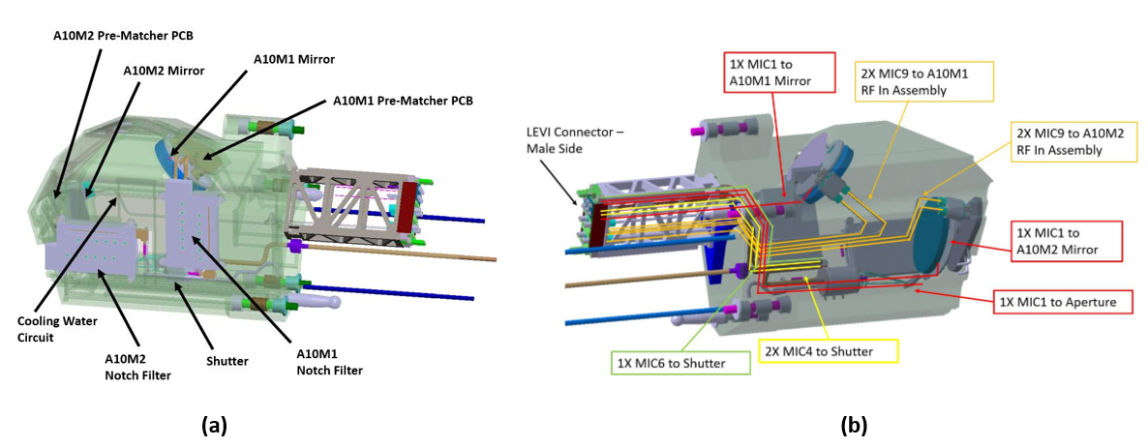

Figure 20. (a)First mirror locations and instrumentation in Bullnose (b) MIC cable routing   
to first mirrors delivering RF power

Each A10 mirror in mirror cleaning system contains RF generator located in diagnostic hall, RF active matchers located in BEOC, passive pre‑matcher unit in bullnose, and RF power carrying cables. RF generator provides RF power at 60Mhz, which is impedance matched by RF active matchers before sending to the pre‑matcher. RF active matchers are tunable using parameters and algorithms to provide stable, consistent plasma generation. A10 mirrors are cleaned simultaneously. Mirror cleaning signal chain is shown in Figure 21.

**Mirror Cleaning Phases** ‑ Mirror Cleaning has complex software control workflow that is coordinated between 55.GA, diagnostic control group (D1), and Supervision and Automation (SUP). A detailed operation procedure is described in [23]. Brief explanation of mirror cleaning phases is given below,

Need for Mirror Cleaning – 55.GA performs regular transmission monitoring procedure described in Section 3.3.3. Based on transmission monitoring co‑efficient, 55.GA personal evaluates the need for mirror cleaning. A flag containing recipe, urgency and, duration is sent to diagnostics (D1) specifying 55.GA needs mirror cleaning. The cleaning phase requires injection of gas in the vacuum vessel. Mirror cleaning can be executed during TCS.

Mirror cleaning Readiness & Start ‑ After 55.GA receives flag from D1 to participate in upcoming mirror cleaning, 55.GA must execute a sequence to get ‘ready’. The Bullnose shutter is opened, and all the RF components are loaded into required settings. Forward power and reverse power are monitored at the RF matcher. To limit cross contamination both mirrors are cleaned simultaneously. D1 send ‘trigger’ to start mirror cleaning to 55.GA once gas pressure inside vacuum vessel is nominal. The 55.GA operator will decide to start mirror cleaning.

Mirror Cleaning Stop Conditions – 55.GA operator can stop or pause mirror cleaning anytime during the process. Mirror cleaning is also stopped automatically using software if excess reverse power is detected. D1 can terminate mirror cleaning anytime during the process and sends the ‘terminate’ flag to 55.GA. Mirror cleaning for 55.GA stops at the end of allotted time slot. Operator can perform transmission monitoring described in Section 3.3.3 during or at the end of the process by pausing mirror cleaning and closing bullnose shutter.

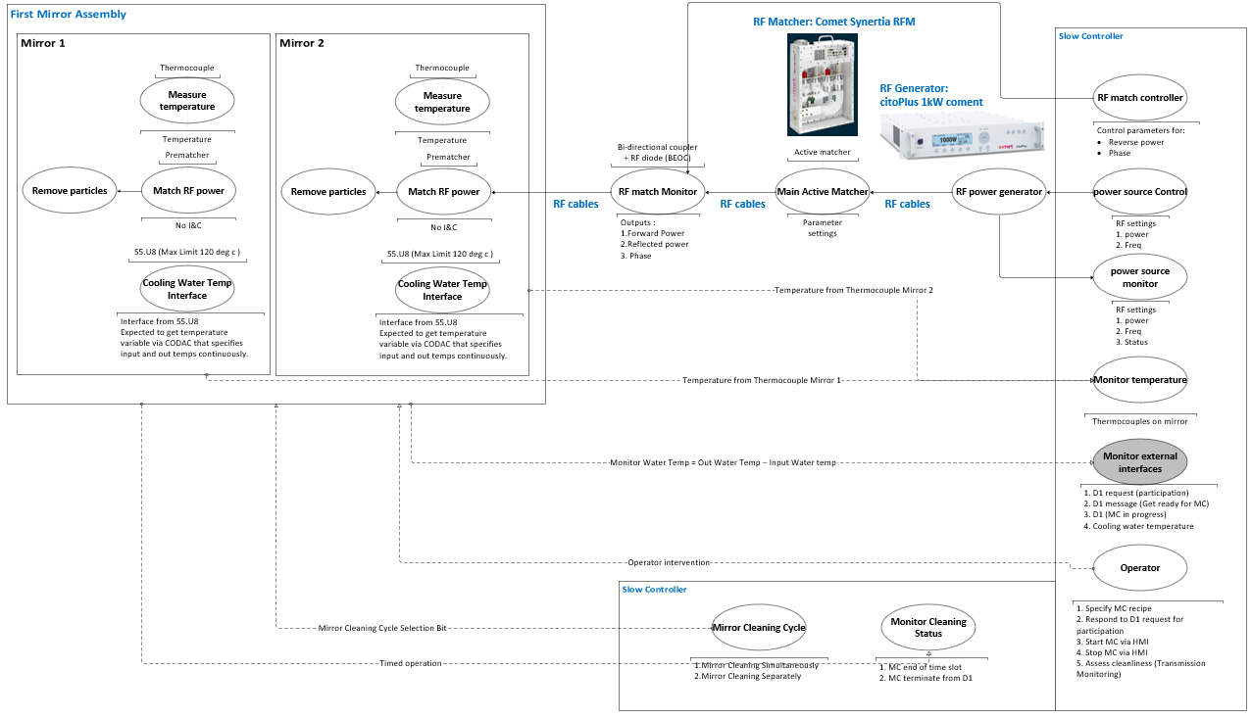

Figure 21. 55.GA mirror cleaning signal chain.

### Mirror Cleaning Components

A block diagram of the mirror cleaning system is shown in Figure 22 and is described in detail in [26]. Therefore, this section will be limited to describing the I&C components involved. A prototype system is currently under development and the design is likely to evolve.

At present the system is composed of two identical RF delivery systems, one for each mirror within the bullnose. The components requiring Instrumentation and Control are the two RF generators located in the diagnostic hall and the associated active matching networks located in the BEOC. The final power requirement of the RF generators has not been finalized as it will have to account for the total transmission loss and the power required by the plasma. The total loss will be determined in the FDR phase. However, at present the RF Generator is expected to be capable of at least 1 kW of power at 60 MHz. Fortunately, commercial RF generators are available in excess of 5 kW at 60 MHz. At present the prototype effort uses a Comet Cito Plus 6010, 60 MHz and 1 kW RF generator for each mirror and this unit will serve as the baseline design (Figure 23). The active matcher selected for the prototype test is the Comet AGS 6020 (shown in Figure 24).

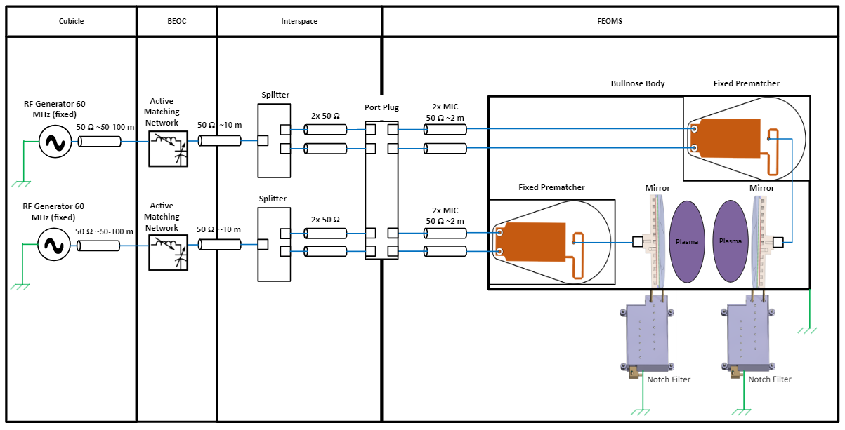

Figure 22. RF mirror cleaning system schematic, simplified to show the basic   
RF system elements.

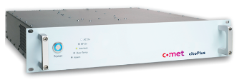

Figure 23. Commercial 60 MHz, 1 kW RF generator.

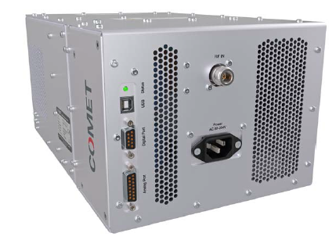

Figure 24. Active Matching Network

Control and monitoring of the generators is done through the Slow Controller using the Profinet protocol. The generators interface with the active matchers through hardwired analog and digital signals between them. The active matchers also provide several control and monitoring signals that are wired to the PLC IO modules. This approach will be refined and tested with the prototype test stand during final design phase.

### Mirror Cleaning BOM

The I&C components used for the RF mirror cleaning system are listed in Table 9 below. Note the Siemens PLC listed is the Plant System Slow Controller.

Table 9. Mirror Cleaning BOM

| Device | Manufacturer Number/ ITER Part Number |
| --- | --- |
| RF Generator, M1 | Comet Cito Plus 6010 |
| Active Matcher, M1 | Comet AGS 6020 |
| RF Generator, M2 | Comet Cito Plus 6010 |
| Active Matcher, M2 | Comet AGS 6020 |
| PLC Slow Controller | SM531‑8AI /  6ES7531‑7KF00‑0AB0 |

## Shutter Control System

Each UWAVS port has a single in‑vessel shutter to protect the first two in‑vessel mirrors from contamination during events such as Glow Discharge Conditioning (GDC), Ion Cyclotron Wall Conditioning (ICWC), and Electron Cyclotron Wall Conditioning (ECWH). The system is detailed in [27]. The shutter includes a heated calibration filament that is mounted on the shutter aperture for optical transmission monitoring, the control of which is discussed further in Section 3.3.3. An illustration of the shutter is shown in Figure 25 for reference.



Figure 25. In‑vessel shutter architecture shown without calibration filament and cables

The in‑vessel shutter is pneumatically operated and is designed to use a gas control box concept identical to Diagnostic 55.E2 (H‑alpha) to drive the pneumatic bellow actuator. The gas control box employs a series of sensors and actuators including solenoids, gate valves, pressure sensors, pressure regulators, and limit switches. A schematic of the valve‑box design has been extracted from the UWAVS Piping & Instrumentation Diagram (P&ID) for illustration purposes. The reader should reference the P&ID for any UWAVS port for a high‑resolution viewing [2].

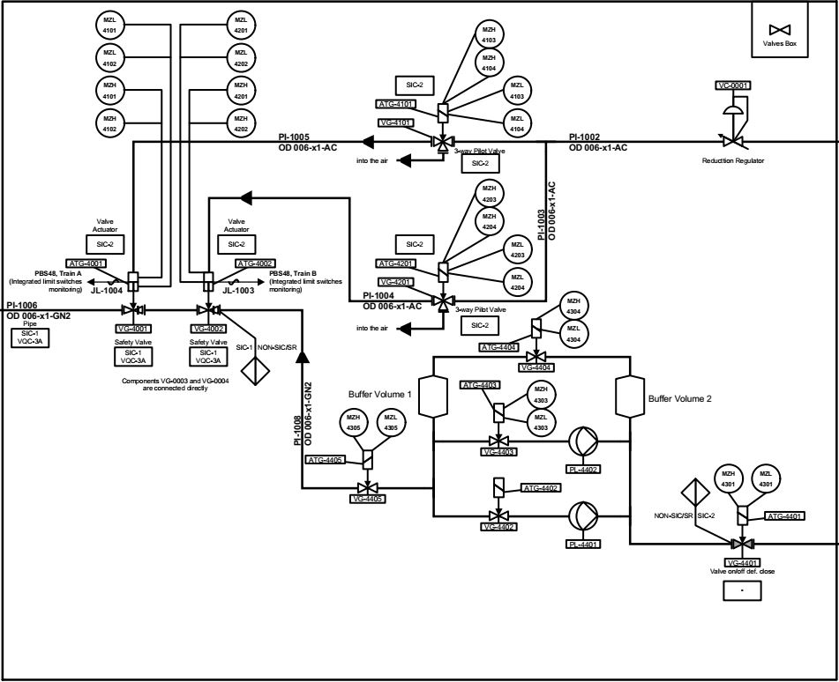

Figure 26. Shutter control box schematic for 55‑GA.A0 extracted from the P&ID

Each valve box will be controlled using the Slow Controller assigned to that port with IO modules suitable for the signals. The particular make and model of each actuator has yet to be chosen but the design will follow the development of 55.E2, providing a common solution to a common problem. It is expected that each of components will have industry‑standard control and monitoring signals (ie, 24V solenoid drive and relays, 24V limit switches, 4‑20mA or 0‑10V signal transmitters, etc.) so the number and type of PLC IO modules can be selected.

### Shutter Control System Components

The in‑vessel shutter will be controlled using the Slow Controller (with IO modules) assigned to that port. The controller and modules used are listed in Table 10.

Table 10. Shutter Control System BOM

| Device | Manufacturer Number/  ITER Part Number | Quantity |
| --- | --- | --- |
| Slow controller (Siemens S7 1500 PLC) | 6ES7516‑3AN01‑0AB0 | 1 |
| 24 VDC/3A stabilized power module | PM1500‑3A / 6EP1332‑4BA00 | 1 |
| 8‑Ch Analog Inputs Module U/I/RTD/TC | SM531‑8AI/ 6ES7531‑7KF00‑0AB0 | 1 |
| 32 DO Module with Diagnosis | SM522‑32DO/6ES7522‑1BL01‑0AB0 | 1 |
| 32 DI module with Diagnosis | SM521‑32DI /6ES7521‑1BL00‑0AB0 | 1 |

## Image Acquisition and Processing System

The hardware devices foreseen in UWAVS hardware architecture is based on devices available in the Fast Controller catalog [28]. The data acquisition of the cameras will be performed by using a DAQ MTCA chassis and the data processing will be performed on CPU and GPU in a DAQ Fast Controller.

### MTCA Chassis

The MTCA‑12‑P‑ML reference is foreseen. As it implements 12 slots, while only 2 cameras have to be controlled per chassis. However, this model has the benefit of proposing fan and power supply redundancy.

Two configurations are possible and could be discussed during the PDR:

Both IR cameras are handled by a same chassis (and consequently the visible ones by the other one) in aim of performing bi‑color measurements

Each chassis handles an IR and a visible camera in aim of having similar MTCA chassis configuration.



Figure 27. DAQ MTCA.4 I/O Chassis.

### DAQ Grade HDEC PC Computers

The ID1812‑B‑004/ITER reference is foreseen because it embeds a GPU board considering that some algorithms will be implemented on GPU in order to fulfill latency requirements. In accordance with the “Plant System I&C Architecture Technical Specifications” (ITER_D_32GEBH), one I&C Fast Controller is required for the DAQ Fast Controllers supervision and for communication with SDN network. The ID1549‑A‑006/ITER reference is foreseen for supervising the DAQ Grade HDES PC computers.



Figure 28. HDEC PC Computer.

### 10GigE Frame Grabbers

A DAQ prototyping activity aims to output a 10GigE frame grabber model based on the Image Reference System frame grabbers. This prototype will also assess the ability of the DAQ system to acquire images from several 10GigE cameras, a dedicated frame grabber per camera, without frame loss, frame corruption.

### Power Supplies

A Caen SY5527LC power supply chassis equipped with 2 A2553 (A) modules to supply the IR cameras (2), the visible cameras (2), potentially the media converters (4) if the cameras are not fiber embedded, and to trig the cameras (4) if the triggering is not achieved by the 10GigE link. For system availability reasons, the Data Acquisition and Process channel is split into two channels by using two DAQ MTCA chassis, each of them managed by a DAQ Fast Controller.



Figure 29. Caen power supply for camera

### Circuit Breakers

Schneider Electric circuit breakers 2P, 6A, C curve, 230 VAC (A9F77206) are foreseen for the Fast controllers and the MTCA chassis. A Schneider Electric circuit breaker 2P, 10A, C curve, 230 VAC (A9F77210) is foreseen for the Power Supply.

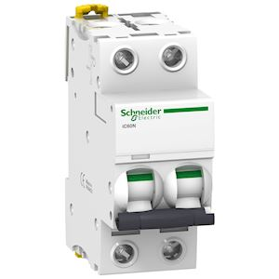

Figure 30. Schneider Circuit Breaker

### IR Cameras

The 55.GA camera selection is not baselined in preliminary design.  A selection of cameras is assumed during preliminary design to support optical analysis and design integration activities. The Infratec ImageIR 10300 IR camera was used for optical analysis as it offers the most pixels (1920x1536) in the camera series. However, the Infratec 9300 model was used for design integration purposes. This model has fewer pixels (1280x1024) but includes a water-cooled configuration and 3D models were available. The 9300 and 10300 size is comparable, they share a similar form factor, and both leverage the 10GigE interface. The 10GigE interface allows long-distance, high-speed data transmission. Infratec confirmed the 10300 can be modified with a water-cooled configuration, but it is not available standard at this time. An updated camera survey is planned in final design and the baseline camera assumptions will be revisited at that time. The technical specifications for the Infratec 10300 [29] are presented in Table 11.

Table 11. Technical Specifications of Infratec ImageIR 10300

|  |  |
| --- | --- |
| **Technical Specifications** | |
| Spectral range | (3.6 … 4.9) µm |
| Pitch | 10 µm |
| Detector | InSb |
| Detector format (IR pixels) | (1,920 × 1,536) |
| Image recording principle | Snapshot |
| Readout mode | ITR / IWR |
| Aperture | f/2.0 |
| Detector cooling | Stirling cooler |
| Temperature measuring range | (-40 … 1,200) °C, up to 3,000 °C* |
| Measurement accuracy | ± 1 °C or ± 1 % |
| Temperature resolution at 30 °C | Better than 0.035 K/0.0022k in high-speed mode |
| Frame rate | Up to 113 / 216 / 396 / 1,915 Hz  High-speed mode: up to 400 / 692 / 1,088 / 2,493 Hz |
| Focus | Manual, motorized or automatic |
| Dynamic range | 13 bit |
| Integration time | (1…..20,000) micro secs |
| Rotating aperture wheel and filter wheel | Up to 7 positions |
| Interfaces | 10GigE, HDMI |
| Trigger | 4 IN/2 OUT, yes |
| Analog Signals, IRIG-B | 2 IN / 2 OUT, yes |
| Power Supply | 24 V DC, wide-range power supply (100…240) V DC |
| Window mode | Yes |

### Visible Cameras

Two Separate camera models are temporarily selected for visible channels. EMV HT-12000 camera is selected for high resolution imaging. This camera offers 10GigE base interface. Using CAT6A cabling, it allows cable length up to 100 meters. The technical specifications are provided in Table 12.

Table 12. Technical Specifications of EMV HT-12000

|  |  |
| --- | --- |
| **Technical Specifications** | |
| Light Sensitive Pixels | 4096 x 3072 |
| Exposure/Integration | 10us—1s |
| Sensor | 28mm CMOSIS CMV12000 |
| Pixel Size | 5.5um (square) |
| Frame Rate | 84 fps |
| Dynamic Range | 60 dB |
| Optical Format | 28mm, M42x1x12mm BFL,F-mount Avail |
| Triggering | Software, External (Pulse or Edge) |
| Digital Output | 8, 10 bit |
| Interface | 10GigE 10GBaseT |
| Monochrome Modes | Mono8, Mono10 |
| Color Modes | RGB8, YUV411, YUV422, YUV444 BGR8 |
| Raw Modes | BayerGR8, BayerGR10 |
| Frame Buffer | 20 frames (8bpp, Full Frame) |
| Onboard Algorithm Support | On Request |
| Memory | 250MB DDR2, 125MB NOR FLASH |
| Operating System | Windows 7/8, Linux (eCapture, eSDK) |
| Dimensions | 95 x 58 x 50 mm (w/o F-mount) |
| Weight | 350g |
| Power Requirements | 11W, 12V, Includes Heatsink |
| Operating Temperature | 0 — 45C |
| Storage Temperature | -30 to +60C |
| Compliance | CE, FCC, RoHS, WEEE, GigE Vision, GenICam |

The Mikrotron EoSens 4CPX6 visible camera is uses for high-speed image capturing. This camera captures images at 563 frames per second and has ability to achieve higher frame rates by defining up to three independent regions of interest. The technical specifications are provided in Table 13.

Table 13. Technical Specifications of Mikrotron EoSens 4CPX6

|  |  |
| --- | --- |
| **Technical Specifications** | |
| Resolution [MP] | 4 MP |
| Resolution (h x v) | 2336 x 1728 px |
| Frame rate (max.) | 563 fps |
| Chroma | mono (color on request) |
| Interface | CXP-6 with 4 Connections |
| 2336 x 1920 | 563 fps |
| 1920 x 1080 | 900 fps |
| 1024 x 768 | 1264 fps |
| Exposure modes | EXTERNAL |
| Trigger modes | Button, External TTL Signal, CXP-Trigger |
| Exposure time (min) | 1 µs |
| Exposure time (max) | 1 sec (external ∞) |
| Pixel format / max | mono8, mono10 / 10 bit |
| nput up to 24V | 2 x |
| Input Galvanic | 2 x |
| Output Galvanic | 2 x |
| Power supply | 12 to 24 V (DC) |
| Power consumption | 10 W (dep. on operating mode) |

### Filter Wheel Assembly

Each visible camera has a filter wheel assembly associated with it that consists of filters wheels, stepper motors, and limit switches. There are three filter wheels on each filter wheel assembly, with each filter wheel having six filter selections. The filter wheels have a ‘home position’ switch that can be used for configuration and troubleshooting. At the start of normal operations or visible camera calibration procedures, 55.GA imports configuration from CODAC including the filter ID. A lookup tables converts Filter ID request from CODAC to filter wheel number and physical filter ID and uses stepper motors to move the filters in position. The stepper motors and limit switches need to be radiation hardened due to radiation exposure in BEOC. Filter wheels assembly is shown in Figure 31. The detailed mechanical design for filter wheels described in [21].

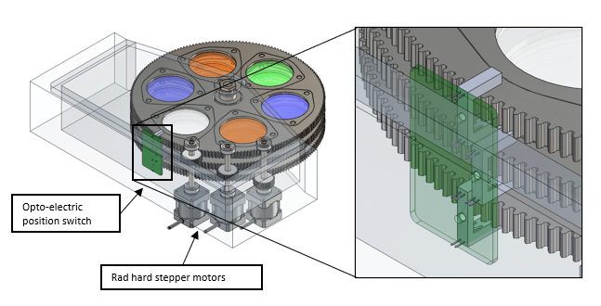

Figure 31. Filter wheel Assembly with its components.

### Filter Wheel Components

During any operation that requires visible cameras, a filter wheel ID needs to be configured or known for accurate measurement. Each filter wheel has a rad hard stepper motor, motor and rad hard homing limit switch. As shown in Figure 32, both are controlled by a slow controller. All the components of filter wheel assembly are same as described in Section 3.2.3, Section 3.2.4, Section 3.2.5.

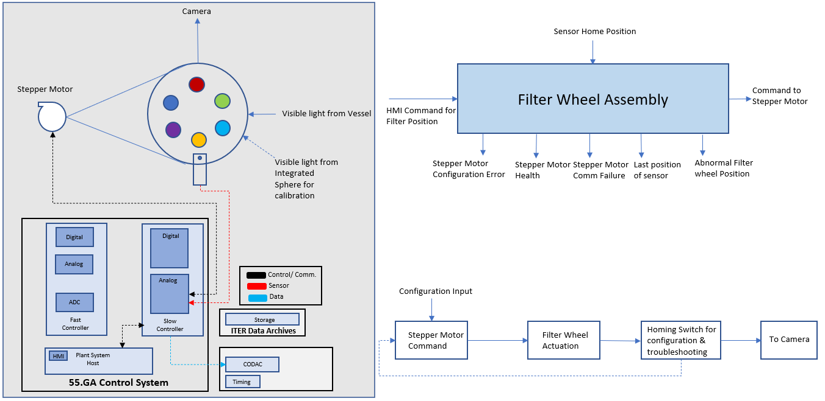

Figure 32. I&C functions of filter wheel

## COTS Checklist

All COTS devices listed in the previous sections can be integrated in the control system. The interface to most devices is either Ethernet or Serial. Some devices are interfaced PLC slow controller.

### IR Camera

IR cameras preliminary Selection – Infratec ImageIR 10300

Table 14. COTS Checklist for IR camera

| Y = YES  N = No  I = Impossible  R = Requires Dev. Work  P = Perf. Issue  ? = Need Investigation  0 = No Need | Native Software support in both ends | Black Box  (Ethernet + IOC) | FC integration with RHEL Linux | FC with RHEL virtualized Windows with shared memory | Implementation in standard fast controller with CCS |
| --- | --- | --- | --- | --- | --- |
| Configuration (User) | Y | 0 | 0 | 0 | Y |
| Measurement | 0 | 0 | 0 | 0 | 0 |
| Real Time (SDN) | 0 | 0 | 0 | 0 | 0 |
| Timing | 0 | 0 | 0 | 0 | 0 |
| Raw Data Acquisition | Y | 0 | 0 | 0 | Y |
| Archiving (DAN) | 0 | 0 | 0 | 0 | 0 |
| Health Management | Y | 0 | 0 | 0 | Y |
| Calibration | 0 | 0 | 0 | 0 | 0 |
| Automation (PSOS) | 0 | 0 | 0 | 0 | 0 |
| Production State | 0 | 0 | 0 | 0 | 0 |
| Quality Flag | 0 | 0 | 0 | 0 | 0 |
| HW Obsolescence | 0 | 0 | 0 | 0 | 0 |
| SDD Integration | 0 | 0 | 0 | 0 | 0 |

### Visible camera

Visible cameras preliminary selection – EMV HT-12000, Mikrotron EoSens 4CPX6

Table 15. COTS Checklist for EMV HT-12000

|  |  |  |  |  |  |
| --- | --- | --- | --- | --- | --- |
| Y = YES  N = No  I = Impossible  R = Requires Dev. Work  P = Perf. Issue  ? = Need Investigation  0 = No Need | Native Software support in both ends | Black Box  (Ethernet + IOC) | FC integration with RHEL Linux | FC with RHEL virtualized Windows with shared memory | Implementation in standard fast controller with CCS |
| Configuration (User) | Y | **0** | 0 | 0 | Y |
| Measurement | 0 | **0** | **0** | 0 | 0 |
| Real Time (SDN) | 0 | **0** | **0** | 0 | 0 |
| Timing | 0 | **0** | **0** | 0 | 0 |
| Raw Data Acquisition | Y | **0** | 0 | 0 | Y |
| Archiving (DAN) | 0 | **0** | **0** | 0 | 0 |
| Health Management | Y | **0** | 0 | 0 | Y |
| Calibration | 0 | **0** | **0** | 0 | 0 |
| Automation (PSOS) | 0 | **0** | **0** | 0 | 0 |
| Production State | 0 | **0** | **0** | 0 | 0 |
| Quality Flag | 0 | **0** | **0** | 0 | 0 |
| HW Obsolescence | 0 | **0** | **0** | 0 | 0 |
| SDD Integration | 0 | **0** | **0** | 0 | 0 |

Table 16. COTS Checklist for Mikrotron EoSens 4CPX6

|  |  |  |  |  |  |
| --- | --- | --- | --- | --- | --- |
| Y = YES  N = No  I = Impossible  R = Requires Dev. Work  P = Perf. Issue  ? = Need Investigation  0 = No Need | Native Software support in both ends | Black Box  (Ethernet + IOC) | FC integration with RHEL Linux | FC with RHEL virtualized Windows with shared memory | Implementation in standard fast controller with CCS |
| Configuration (User) | Y | **0** | Y | 0 | 0 |
| Measurement | 0 | **0** | **0** | 0 | 0 |
| Real Time (SDN) | 0 | **0** | **0** | 0 | 0 |
| Timing | 0 | **0** | **0** | 0 | 0 |
| Raw Data Acquisition | Y | **0** | Y | 0 | 0 |
| Archiving (DAN) | 0 | **0** | **0** | 0 | 0 |
| Health Management | Y | **0** | Y | 0 | 0 |
| Calibration | 0 | **0** | **0** | 0 | 0 |
| Automation (PSOS) | 0 | **0** | **0** | 0 | 0 |
| Production State | 0 | **0** | **0** | 0 | 0 |
| Quality Flag | 0 | **0** | **0** | 0 | 0 |
| HW Obsolescence | 0 | **0** | **0** | 0 | 0 |
| SDD Integration | 0 | **0** | **0** | 0 | 0 |

### Caen Power Supply for Cameras

Table 17. COTS Checklist for 6.1.3. Caen Power Supply

| Y = YES  N = No  I = Impossible  R = Requires Dev. Work  P = Perf. Issue  ? = Need Investigation  0 = No Need | Native Software support in both ends | Black Box  (Ethernet + IOC) | FC integration with RHEL Linux | FC with RHEL virtualized Windows with shared memory | Implementation in standard fast controller with CCS |
| --- | --- | --- | --- | --- | --- |
| Configuration (User) | 0 | **0** | **0** | 0 | Y |
| Measurement | 0 | **0** | **0** | 0 | 0 |
| Real Time (SDN) | 0 | **0** | **0** | 0 | 0 |
| Timing | 0 | **0** | **0** | 0 | 0 |
| Raw Data Acquisition | 0 | **0** | **0** | 0 | 0 |
| Archiving (DAN) | 0 | **0** | **0** | 0 | 0 |
| Health Management | 0 | **0** | **0** | 0 | Y |
| Calibration | 0 | **0** | **0** | 0 | 0 |
| Automation (PSOS) | 0 | **0** | **0** | 0 | 0 |
| Production State | 0 | **0** | **0** | 0 | 0 |
| Quality Flag | 0 | **0** | **0** | 0 | 0 |
| HW Obsolescence | 0 | **0** | **0** | 0 | 0 |
| SDD Integration | 0 | **0** | **0** | 0 | 0 |

### Stepper Motor Controllers PIC‑663

Table 18. COTS Checklist for Motor Controller

| Y = YES  N = No  I = Impossible  R = Requires Dev. Work  P = Perf. Issue  ? = Need Investigation  0 = No Need | Native Software support in both ends | Black Box  (Ethernet + IOC) | FC integration with RHEL Linux | FC with RHEL virtualized Windows with shared memory | Implementation in standard fast controller with CCS |
| --- | --- | --- | --- | --- | --- |
| Configuration (User) | Y | Y | 0 | 0 | 0 |
| Measurement | Y | Y | 0 | 0 | 0 |
| Real Time (SDN) | 0 | 0 | 0 | 0 | 0 |
| Timing | 0 | 0 | 0 | 0 | 0 |
| Raw Data Acquisition | Y | Y | 0 | 0 | 0 |
| Archiving (DAN) | 0 | 0 | 0 | 0 | 0 |
| Health Management | Y | Y | 0 | 0 | 0 |
| Calibration | 0 | 0 | 0 | 0 | 0 |
| Automation (PSOS) | R | R | 0 | 0 | 0 |
| Production State | R | R | 0 | 0 | 0 |
| Quality Flag | R | R | 0 | 0 | 0 |
| HW Obsolescence | R | R | 0 | 0 | 0 |
| SDD Integration | R | R | 0 | 0 | 0 |

### RF generator – COMET cito plus 6010

Table 19. COTS Checklist for RF generator

| Y = YES  N = No  I = Impossible  R = Requires Dev. Work  P = Perf. Issue  ? = Need Investigation  0 = No Need | Native Software support in both ends | Black Box  (Ethernet + IOC) | FC integration with RHEL Linux | FC with RHEL virtualized Windows with shared memory | Implementation in standard fast controller with CCS |
| --- | --- | --- | --- | --- | --- |
| Configuration (User) | Y | Y | 0 | 0 | 0 |
| Measurement | Y | Y | 0 | 0 | 0 |
| Real Time (SDN) | 0 | 0 | 0 | 0 | 0 |
| Timing | 0 | 0 | 0 | 0 | 0 |
| Raw Data Acquisition | Y | Y | 0 | 0 | 0 |
| Archiving (DAN) | 0 | 0 | 0 | 0 | 0 |
| Health Management | Y | Y | 0 | 0 | 0 |
| Calibration | 0 | 0 | 0 | 0 | 0 |
| Automation (PSOS) | R | R | 0 | 0 | 0 |
| Production State | R | R | 0 | 0 | 0 |
| Quality Flag | R | R | 0 | 0 | 0 |
| HW Obsolescence | R | R | 0 | 0 | 0 |
| SDD Integration | R | R | 0 | 0 | 0 |

### RF Active Matcher – COMET AGS 6020

Table 20. COTS Checklist for RF Active Matcher

|  |  |  |  |  |  |
| --- | --- | --- | --- | --- | --- |
| Y = YES  N = No  I = Impossible  R = Requires Dev. Work  P = Perf. Issue  ? = Need Investigation  0 = No Need | Native Software support in both ends | Black Box  (Ethernet + IOC) | FC integration with RHEL Linux | FC with RHEL virtualized Windows with shared memory | Implementation in standard fast controller with CCS |
| Configuration (User) | Y | Y | 0 | 0 | 0 |
| Measurement | Y | Y | 0 | 0 | 0 |
| Real Time (SDN) | 0 | 0 | 0 | 0 | 0 |
| Timing | 0 | 0 | 0 | 0 | 0 |
| Raw Data Acquisition | Y | Y | 0 | 0 | 0 |
| Archiving (DAN) | 0 | 0 | 0 | 0 | 0 |
| Health Management | Y | Y | 0 | 0 | 0 |
| Calibration | 0 | 0 | 0 | 0 | 0 |
| Automation (PSOS) | R | R | 0 | 0 | 0 |
| Production State | R | R | 0 | 0 | 0 |
| Quality Flag | R | R | 0 | 0 | 0 |
| HW Obsolescence | R | R | 0 | 0 | 0 |
| SDD Integration | R | R | 0 | 0 | 0 |

### Keysight N6700 Power Supplies

Table 21. COTS Checklist for Keysight N6700 Power Supplies

| Y = YES  N = No  I = Impossible  R = Requires Dev. Work  P = Perf. Issue  ? = Need Investigation  0 = No Need | Native Software support in both ends | Black Box  (Ethernet + IOC) | FC integration with RHEL Linux | FC with RHEL virtualized Windows with shared memory | Implementation in standard fast controller with CCS |
| --- | --- | --- | --- | --- | --- |
| Configuration (User) | Y | Y | 0 | 0 | 0 |
| Measurement | Y | Y | 0 | 0 | 0 |
| Real Time (SDN) | 0 | 0 | 0 | 0 | 0 |
| Timing | 0 | 0 | 0 | 0 | 0 |
| Raw Data Acquisition | Y | Y | 0 | 0 | 0 |
| Archiving (DAN) | 0 | 0 | 0 | 0 | 0 |
| Health Management | Y | Y | 0 | 0 | 0 |
| Calibration | 0 | 0 | 0 | 0 | 0 |
| Automation (PSOS) | R | R | 0 | 0 | 0 |
| Production State | R | R | 0 | 0 | 0 |
| Quality Flag | R | R | 0 | 0 | 0 |
| HW Obsolescence | R | R | 0 | 0 | 0 |
| SDD Integration | R | R | 0 | 0 | 0 |

### Blackbody Source Controller ‑ Advanced Energy M330

Table 22. COTS Checklist for Blackbody Source Controller – Advanced Energy M330

| Y = YES  N = No  I = Impossible  R = Requires Dev. Work  P = Perf. Issue  ? = Need Investigation  0 = No Need | Native Software support in both ends | Black Box  (Ethernet + IOC) | FC integration with RHEL Linux | FC with RHEL virtualized Windows with shared memory | Implementation in standard fast controller with CCS |
| --- | --- | --- | --- | --- | --- |
| Configuration (User) | Y | Y | 0 | 0 | 0 |
| Measurement | Y | Y | 0 | 0 | 0 |
| Real Time (SDN) | 0 | 0 | 0 | 0 | 0 |
| Timing | 0 | 0 | 0 | 0 | 0 |
| Raw Data Acquisition | Y | Y | 0 | 0 | 0 |
| Archiving (DAN) | 0 | 0 | 0 | 0 | 0 |
| Health Management | Y | Y | 0 | 0 | 0 |
| Calibration | Y | 0 | 0 | 0 | 0 |
| Automation (PSOS) | R | R | 0 | 0 | 0 |
| Production State | R | R | 0 | 0 | 0 |
| Quality Flag | R | R | 0 | 0 | 0 |
| HW Obsolescence | R | R | 0 | 0 | 0 |
| SDD Integration | R | R | 0 | 0 | 0 |

# Cubicle configuration

## Cubicle Layouts

Each of the five 55.GA systems have identical I&C controllers and components independent to each installation. Each installation utilizes two I&C Local Control Cubicles (LCC) with the general distribution of equipment shown in Figure 33. One cubicle is designated as the “Camera Cubicle” and houses the fast controllers (PCF), camera capture electronics, camera power supplies, and supervisory PCF. The second cubicle, designated the “Support Cubicle”, contains the remainder of the equipment required to control and operate the system including the slow controller, motor controller, master controller, and RF plasma generators. Some control equipment for Ports 2 and 17 may be co‑located in a shared cubicle in the North‑East Shielded Corner. This is described in Section 4.1.5.

An eleventh additional cubicle has been allocated to serve as a “Common Cubicle” and will house the 55.GA Plant System Host (PSH)/mini‑CODAC system during commissioning.

A twelfth “Gallery Cubicle” has been assigned to UWAVS but is currently not used in the base design. This cubicle was originally owned by NEX0 to serve as a shared cubicle but was subsequently transferred to 55.GA due to lack of need and the cost associated with powering and shielding it. This cubicle is further described in Section 4.1.4.



Figure 33. Front‑views of the two cubicles used for each UWAVS installation, designated “Camera Cubicle” and “Support Cubicle.”

Design of internal layout follows guidelines in Section 3 of ITER I&C cubicle internal configuration document [30] where possible. High heat generating components are placed downstream of low heat dissipating components as long as that is possible in relation to requirement that components within the cubicle are laid out in an accessible and logically segregated manner [31].

Ideally weight distribution of cubicle should be done in a way where heaviest devices are placed at the lower part of the cubicle. However, in some instances this principle cannot be followed as the heavier devices tend to produce more heat. In addition, lower part of the cubicle needs sufficient clearance from the cooler fan. Nevertheless, the heaviest devices were not put in the highest part of the cubicle.

Guidelines on internal configuration also require to respect clearances for components as specified by manufacturers. For most of the devices, manufacturers specify exact clearances. These clearances are respected and implemented with installations of front 1U panels at the top/bottom of the device.

The 55.GA cubicle layouts, power, and heat load analysis are computed in a spreadsheet and imported into this document. The detailed component placement in each LCC is presented in the scheme below, for each cubicle individually.

### Camera Control Cubicle

The “Camera Cubicle” layout for a representative port is shown in Figure 34.



Figure 34. 55.GA “Camera Cubicle” LCC layout

### Support Control Cubicle

The “Support Cubicle” layout for a representative port is shown in Figure 35. In addition to having sections of standard 19” rack mounted equipment, this layout has an internal panel for mounting DIN‑rail type PLC IO modules, signal conditioning modules, and wiring blocks.



Figure 35. 55.GA “Support Cubicle” LCC layout

### Common Cubicle

There is a single cubicle common to all UWAVS chords. This cubicle will initially house the mini‑CODAC system during system integration or the Plant System Host (PSH) during commissioning. The PSH will later be virtualized.

*Note: there is some confusion amongst the designers about how the PSH is deployed. Several other diagnostics we have surveyed, such as 55.BC (DNFM) indicate a physical PSH located in cubicles, with real connections to PON and TCN.*



Figure 36. 55.GA “Common” LCC layout

### Gallery Cubicle (Not used)

UWAVS owns a single full-size cubicle located in the Gallery (11-L2-02S) just outside the Port Cell for UP#11 (Figure 37.) This cubicle was originally owned by NEX0 to serve as a shared cubicle but was subsequently transferred to 55.GA due to lack of need. We are holding this cubicle in reserve as it may be useful as a contingency against the anticipated large RF signal losses from the RF generators in the diagnostic hall. A considerable savings in cable length (and therefore RF attenuation) can be realized by relocating the RF generators to this cubicle. However, this cubicle is currently un-shielded and un-powered and would require considerable investment to fully utilize.

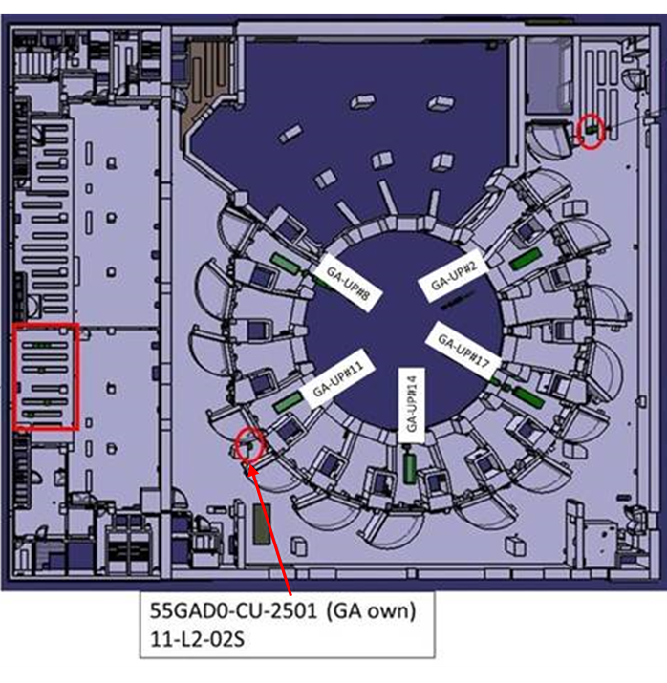

Figure 37. Illustration showing of the Tokamak Building showing the location of the spare cubicle

### North-East Shielded Corner Cubicle (Shared)

UWAVS has been allocated space by 55.NEX0 in a shared cubicle in the North East Shielded Corner to server ports UP#2 and UP#17 (GA.A0 and GA.E0). A space allocation request was captured in an interface spreadsheet (ITER_2P3MJ2) titled “Space Allocation in 55.NEX0 Shared Cubicle”. A total of 16U of space has been requested, with a representative stack-up shown in Figure 38. This assumes that a PON-enabled network switch is available.



Figure 38. Space Allocation requested for the 55.NE.X0 Shared Cubicle Cubicle (as per ITER_2P3MJ2)

## Power Allocation and Heat Load Analysis

All cubicles will have assigned Class IV indefinitely interruptible AC (230/400 V and 6.6 kV) power supplies. The components will be powered through cubicle power distribution and will be protected by miniature circuit breakers (MCB). Standard Cubicle Monitoring System PLCs will be used to monitor proper operation of the cubicle and its included components/units.

### Methodology

The power load and heat dissipation indicated hereafter are given for one port considering that the cubicle layout is the same for the five ports. Therefore, only the worst case is considered.

The power requirements for each cubicle are determined by assessing the power consumption of all components in the cubicles. The approximated power consumption and heat emission of Fast Controller CPUs, network switches, cubicle monitoring PLCs, and fans were obtained by extrapolating the measurements performed by 55.EC [31]. For other known components the datasheets were used. In cases where the exact components are not known yet, the available COTS products have been researched and their power ratings used as a brief assessment with some margins. At the preliminary level, it is assumed that all the power load is heat dissipated unless otherwise noted.

### Camera Control Cubicle

The heat load requirements for a representative Camera Control cubicle are tabulated in Table 23 below. The following assumptions were made in this analysis:

I&C Chassis DAQ MTCA: the maximum absorbed power per unit was assessed on the basis of 80 W per used slots. 4 slots will be used per chassis: 2 single 10GigE Frame grabbers, a timing board (PTM‑DAMC‑1588‑10F) and a board dedicated to communication with the Fast Controller (NAT‑MCH‑PHYS80).

Caen SY5527LC Power Supply (DC): The maximum absorbed power is 700W. As only 2 slots (out of 6) are used, we will consider a 300W maximum absorbed power for our configuration.

I&C Fast Controller CPU: The maximum absorbed power is 800W.

Supervisory Computer: This is the Supervisory Computer called for in the PCDH for systems with multiple PCFs. However, it is likely that it will not be needed as functionality can be implemented in one of the DAQ PCF’s during Final Design. This will bring the cubicle heat load below 2kW.

Table 23. Power and Heat Load Requirements for Camera Control Cubicles

| Index | Description | Nb | Max. absorbed Power per unit (W) | Total Max absorbed Power (W) | Estimated  heat emission (W) |
| --- | --- | --- | --- | --- | --- |
| 1 | Network switch | 1 | 26 | 26 | 26 |
| 2 | Cubicle Monitoring System | 1 | 24 | 24 | 24 |
| 3 | MTCA.4 chassis | 2 | 320 | 640 | 640 |
| 4 | DAQ Fast Controller CPU | 2 | 800 | 1600 | 1000 |
| 5 | I&C Fast Controller CPU**\*** | 1 | 800 | 800 | 500 |
| 6 | Power Supply | 1 | 300 | 300 | 300 |
|  | Total | - | - | 3390 | 2490 |

**\***This is the Supervisory Computer which will likely be removed.

### Support Control Cubicle and Common Cubicle

The heat load requirements for a representative Support Control cubicle are tabulated in Table 24 specific assumption for each device is noted in the rightmost column. In general, it is assumed that both RF generators will be operating together, with the power and heat load based on the COMET datasheet.

Table 24. Power and Heat Load Requirements for Support Cubicles

| Device | 230VAC Current (A) | 230VAC Power (W) | Est. Heat Load  (W) | Notes |
| --- | --- | --- | --- | --- |
| Network Switch MACH104 | 0.1 | 26 | 26.0 | Based on ITER_D_YSMSJH |
| Cubicle Monitoring System ‑ S7 1200 | 0.1 | 24 | 24.0 | Based on ITER_D_YSMSJH |
| Master Device Controller ‑ ID01812‑A‑001/ITER | 3.5 | 800 | 500.0 | Based on ITER_D_YSMSJH May be virtualized |
| Slow Controller (PLC) –  S7 1500 with modules | 0.31 | 72 | 50.0 | Based on ITER_D_YSMSJH |
| Black‑Body Source Controller | N/A | N/A | 2.0 | Power from DCPS Below |
| RF Back reflection monitor | N/A | N/A | N/A | Passive component |
| Step Motor Controller (DH) ‑PI C885.RD with modules | N/A | 0 | 20.0 | Power supplied from DCPS; low duty cycle |
| N6700 DC Power Supply ‑ Keysight N6700 (for Filament) | 4.0 | 920 | 20.0 | Most power delivered to filament |
| N6700 DC Power Supply ‑ Keysight N6700 (Cubicle Equipment) | 2.0 | 460 | 460.0 | Most power dissipated in cubicle |
| Comet RF Generator ‑ M1 | 6.7 | 1541 | 462.3 | Estimated, based on 250W RF load |
| Comet RF Generator ‑ M2 | 6.7 | 1541 | 462.3 | Estimated, based on 250W RF load |
| DC Power Distribution Breakers | N/A | N/A | N/A | Passive component |
| Cubicle Fan | 0.7 | 150 | 20.0 | Based on ITER_D_YSMSJH |
| **Totals** | **24.0** | **5534** | **2046.6** |  |

The heat load requirements for the “Common Cubicle” housing the PSH are shown in Table 25.

Table 25. Power and Heat Load Requirements for Common Cubicle

| Device | 230VAC Current (A) | 230VAC Power (W) | Est. Heat Load  (W) | Notes |
| --- | --- | --- | --- | --- |
| Network Switch MACH104 | 0.1 | 26 | 26.0 | Based on ITER_D_YSMSJH |
| Cubicle Monitoring System ‑ S7 1200 | 0.1 | 24 | 24.0 | Based on ITER_D_YSMSJH |
| Master Device Controller ‑ ID01812‑A‑001/ITER | 3.5 | 800 | 500.0 | Based on ITER_D_YSMSJH May be virtualized |
| DC Power Distribution Breakers | N/A | N/A | N/A | Passive component |
| Cubicle Fan | 0.7 | 150 | 20.0 | Based on ITER_D_YSMSJH |
| Totals | 4.3 | 1000 | 570.0 |  |

The heat load requirements for the NEX0 Shared Cubicle in the NE shielded corner are shown in Table 26 below.

Table 26. Power and Heat Load Requirements for NEX0 Shared Cubicle

| Device | 230VAC Current (A) | 230VAC Power (W) | Est. Heat Load  (W) | Notes |
| --- | --- | --- | --- | --- |
| Step Motor Controller (GA.A0)- PI C885.RD with modules | N/A | 0 | 20 | Power supplied from DCPS; low duty cycle |
| Camera Power Supply (GA.A0) - Caen SY5527 DC Supply | 1.2 | 276 | 55 | Assumes 80% efficiency |
| N6700 DC Power Supply - Keysight N6700 (for Motor Controllers) | 3.0 | 690 | 690 | All power absorbed in cubicle |
| Step Motor Controller (GA.A0)- PI C885.RD with modules | N/A | 0 | 20 | Power supplied from DCPS; low duty cycle |
| Camera Power Supply (GA.A0) - Caen SY5527 DC Supply | 1.2 | 276 | 55 | Assumes 80% efficiency |
| N6700 DC Power Supply - Keysight N6700 (for Motor Controllers) | 3.0 | 690 | 690 | All power absorbed in cubicle |
| **Totals** | **8.4** | **1932** | **1530** |  |

## Cubicle Cooling Configuration

Cooling configuration is specified on the basis of each cubicle total power supply and heat load as specified in the I&C cubicle internal configuration [30].

The cubicle heat loads presented in the previous section indicate that the Support cubicles fall below 2000W including the fans. The Camera Control cubicles also have anestimated heat load below 2000W provided the Supervisory Computer can be removed from the design, as noted in Section 4.2.2

Therefore, all cubicles will use a Category 2 fan (heat dissipation between 1 kW and 2 kW) for means of cubicle cooling. The NSYCVF850M230PF fan with a free flow rate with 1 outlet grille of 718 m3/h is specified. No components in the cubicle will be installed directly in front of the intake cooling fan at the bottom of the cubicle and a 150 mm clearance from the cooling fan shall is respected in accordance with active thermal optimization solutions specified in the *Control Panel Technical Guide* issued by the cubicle manufacture (Schneider Electrical). Similarly, no components are in the proximity of the exhaust at the top of the cubicle. The only component installed at the rear of the cubicle on the level of exhaust filter are one network switch and 1U front panel (which is later replaced with optical fiber cassette if needed). This is in accordance with Section 6.8 of [30].

## Cubicle Enclosure Types

All cubicles will be full‑size Schneider Electric enclosure type A(B): NSYSFRSTVA (B) with U47 configuration and 4x 19” uprights.

## Cubicle Cable Entries

For the specified cubicles, cables should enter from the top gland plate using the ITER standards configuration. However, if cable connection through the top gland plate does not suffice or that is not possible, those cables may exceptionally enter from the bottom.

## Network Interface

Components installed in cubicles, and which are connected to the network via network switch and optical fibre cassette have network interface with Central I&C system using PON, TCN, SDN and DAN networks.

Network requirements for 55.GA have been established through interface with CODAC [32]. The type and number of each connection for each cubicle is tabulated in Table 27 in below.

Table 27. Network Interface Requirements

| Functional Reference | UWAVS Type | Cubicle Location | Number Connections Each Network | | | | | |
| --- | --- | --- | --- | --- | --- | --- | --- | --- |
| PON | TCN | DAN | SDN | p‑PLN | v‑PLN |
| 55GA00‑CU‑0001 | (Common) | 74‑L2‑04 | 1 | 1 | 0 | 1 | 0 | 1 |
| 55GAA0‑CU‑7501 | (A0 Support) | 74‑L2‑04 | 1 | 0 | 0 | 0 | 0 | 1 |
| 55GAA0‑CU‑7502 | (A0 Camera) | 74‑L2‑04 | 1 | 1 | 2 | 2 | 0 | 1 |
| 55GAB0‑CU‑7301 | (B0 Camera ) | 74‑L2‑04 | 1 | 0 | 0 | 0 | 0 | 1 |
| 55GAB0‑CU‑7302 | (B0 Support) | 74‑L2‑04 | 1 | 1 | 2 | 2 | 0 | 1 |
| 55GAC0‑CU‑7301 | (C0 Camera) | 74‑L2‑04 | 1 | 0 | 0 | 0 | 0 | 1 |
| 55GAC0‑CU‑7302 | (C0 Support) | 74‑L2‑04 | 1 | 1 | 2 | 2 | 0 | 1 |
| 55GAD0‑CU‑7301 | (D0 Camera) | 74‑L2‑04 | 1 | 0 | 0 | 0 | 0 | 1 |
| 55GAD0‑CU‑7302 | (D0 Support) | 74‑L2‑04 | 1 | 1 | 2 | 2 | 0 | 1 |
| 55GAE0‑CU‑7501 | (E0 Camera) | 74‑L2‑04 | 1 | 0 | 0 | 0 | 0 | 1 |
| 55GAE0‑CU‑7502 | (E0 Support) | 74‑L2‑04 | 1 | 1 | 2 | 2 | 0 | 1 |
| 55NEX0‑CU‑2101 | (NE Corner) | 11‑L2‑02E | 1 | 0 | 0 | 0 | 0 | 0 |

## LCC Bill of Material

This section contains a BOM dedicated for one port. It should therefore be multiplied by 5 for all ITER needs (Ports 2, 8, 11, 14 and 17). The BOM has been divided into three separate tables, one for each UWAVS cubicle type. For completeness the shielded Back‑End Optics and Cameras (BEOC) enclosure is listed as well in Table 30.

Table 28. LCC Bill Of Material (One Camera Cubicle)

| Device | QTY | Manufacturer | Model/ ITER Part Number |
| --- | --- | --- | --- |
| Floor‑standing cubicle (2‑4kW) | 1 | Schneider Electric | NSYSFRSTVA(E) |
| Cubicle‑monitoring PLC | 1 | Siemens | S7 1200 |
| Network switch | 1 | Hirschmann | MACH104‑20TX‑FR |
| Digital to Fiber converter | 4 | TBC‑TBD | TBC‑TBD |
| MTCA.4 chassis | 2 | PowerBridge | MTCA‑12‑2P‑ML |
| PCI express uplink module | 2 | AIES | MPCIE16‑H4‑T4‑CBL‑2 |
| MTCA Carrier Hub MCH | 2 | NAT | NAT‑MCH PHYS80 |
| AMC module | 2 | AIES | AIES‑PTM‑DAMC‑1588‑10F |
| 10Gige Frame Grabber | 4 | AIES | UFG‑10GE |
| DAQ Fast Controller CPU | 2 | Ecrin | ID01812‑B‑004/ITER |
| I&C Fast Controller CPU | 1 | Ecrin | ID01549‑A‑006/ITER |
| DAQ PCI Express DAN and SDN Connectivity Solutions | 2 | SolarFlare | SFN8522 |
| Power Supply | 1 | Caen | SY5527LC |
| 8 Channel 32 V/3 A Full Floating Channel Board | 2 | Caen | A2553A |
| Circuit Breaker for Fast Controllers and chassis | 5 | Schneider Electric | A9F77206 |
| Circuit Breaker for the Power Supply | 1 | Schneider Electric | A9F77210 |

Table 29. LCC Bill Of Material (One Support Cubicle)

| Device | QTY | Manufacturer | Model/ ITER Part Number |
| --- | --- | --- | --- |
| Floor-standing EMC cubicle | 1 | Schneider | NSYSFRSTVEB |
| Cubicle-monitoring PLC | 1 | Siemens | S7 1200 |
| Network switch (Hirschmann MACH104) | 1 | Hirschmann | MACH104-20TX-FR |
| Slow controller (S7-1500 PLC) | 1 | Siemens | 6ES7516-3AN01-0AB0 |
| Stabilized power module  PM 1507 24 V/3 A | 1 | Siemens | PM1500-3A /  6EP1332-4BA00 |
| 8 Analog Outputs Module | 1 | Siemens | SM532-8AO /  6ES7532-5HF00-0AB0 |
| 8 Analog Inputs Module U/I/RTD/TC | 8 | Siemens | SM531-8AI /  6ES7531-7KF00-0AB0 |
| 32 DO Module with Diagnosis | 2 | Siemens | SM522-32DO /  6ES7522-1BL01-0AB0 |
| 32 DI module with Diagnosis | 3 | Siemens | SM521-32DI /  6ES7521-1BL00-0AB0 |
| Modular DC Power Supply Chassis | 2 | Keysight | N6700 Controller |
| DC Power Supply Modules | 6 | Keysight | N6700 Modules |
| 3U Motor Controller Chassis | 1 | Physik Instrumente | PI C885.RD |
| Motor Controller Card | 20 | Physik Instrumente | PI C-663.12C885 |
| I&C Fast Controller CPU (Master Controller) | 1 | Ecrin | ID01549-A-006/ITER |
| Black Body Source Controller | 1 | Eurotherm | Controller from AE M330 Source |
| RF Signal Monitor | 1 | Custom | TBD |
| RF Generator | 2 | Comet | cito Plus 6010-ACNA-P25A-FN |
| Circuit Breaker for Fast Controllers and chassis | 5 | Schneider Electric | A9F77206 |
| Circuit Breaker for the Power Supply | 1 | Schneider Electric | A9F77210 |

Table 30. LCC Bill Of Material (BEOC Shielded Enclosure)

|  |  |  |  |
| --- | --- | --- | --- |
| Device | QTY | Manufacturer | Model/ ITER Part Number |
| IR Camera | 2 | Infratec | ImageIR 10300 |
| Visible Camera #1 | 1 | EMV | HT-12000 |
| Visible Camera #2 High Speed | 1 | Mikrotron | EoSens 4CPX6 |
| RJ45 to Fiber converter | 4 | TBC-TBD | TBC-TBD |
| Digital to Fiber converter | 4 | TBC-TBD | TBC-TBD |
| Black Body Source | 1 | Advanced Energy | M330 |
| Thermocouple Transmitter | 1 | TBD | TBD |
| White Light Source | 1 | Optronic Laboratories | OL 458-4 (Placeholder) |
| Circuit Breakers | 4 | Schneider Electric | A9F77210 |
| RF Automatching Unit | 2 | Comet | TBD: Matched to  RF Generator |

## Cubicle Locations

The locations of each of the UWAVS cubicles are identified in Figure 39. Planned cubicle locations are listed in Table 27, which should be consistent with the Interface Sheet with CODAC Interface [32]. All cubicles with the exception of the shared shielded corner and spare gallery cubicle are located in the building/room 74‑L2‑04.

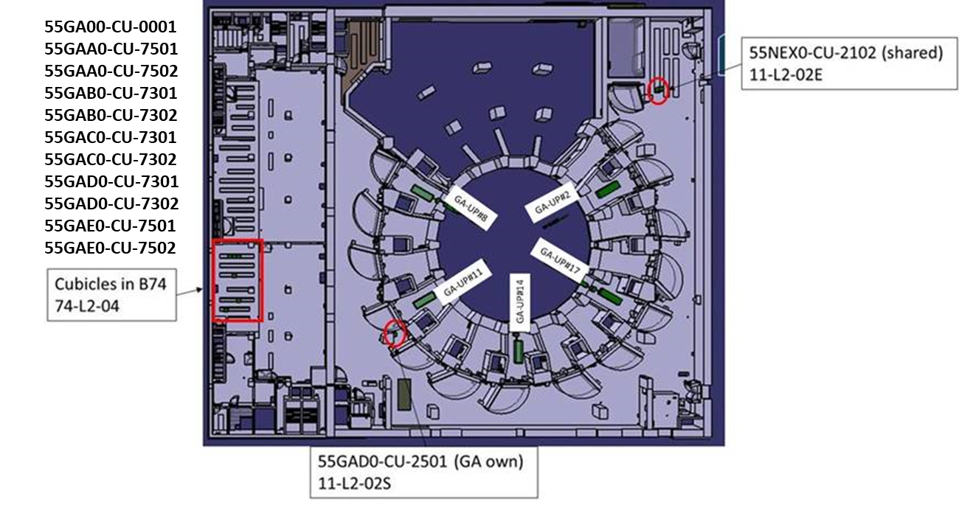

Figure 39. Illustration showing locations of UWAVS Cubicles

# Earthing Concept

All ex-vessel enclosures will have protected, conductive ground path connections to support structures. Optical tables will have ground straps to the enclosures. Calibration source enclosures will have ground straps to the relevant primary enclosure. Telescoping shrouds will have ground straps around sliding joints and conductive flange joints to the enclosure interface. All enclosures will have redundant ground straps to the ISS/PCSS rails to mitigate ground loops. These electrical interfaces are conceptually represented in Figure 40.

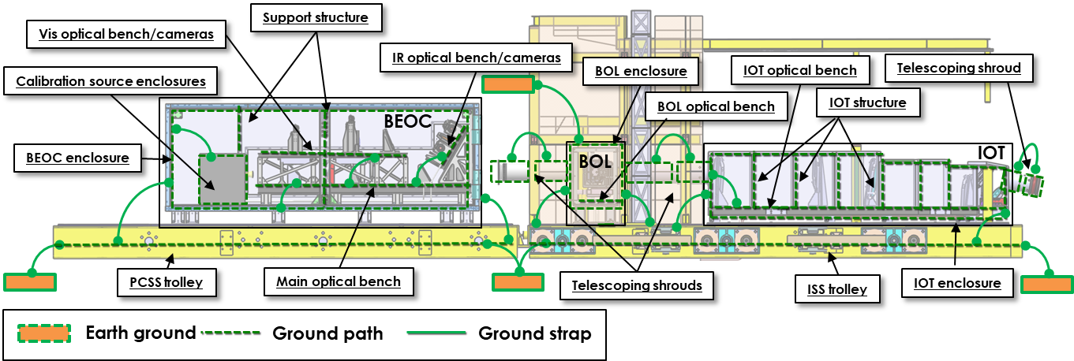

Figure 40. 55.GA earthing concept

Technical description of the interface point, and interface data are provided in Port Integration Interface sheet [33].

# Software Architecture

## Software Architecture Overview

The 55.GA UWAVS control software is distributed over multiple hardware devices located in five locations. In order to propose a better readability, the 55.GA UWAVS software structure will be depicted for only one cubicle considering that this software structure will be replicated for all the other cubicles.



Figure 41. UWAVS Software Structure for Cubicles

The CODAC System sends commands, configuration via PON interface using the channel access protocol to PSH, and PSH sends various data using this interface. This interface is fully defined and configured by self‑description data. The PON interface is mostly used for providing the data for Human Machine Interface accessible in CODAC terminals in CODAC System network. It is also used for providing the data which need to be archived with CSS BEAUTY services. The PON network is additionally used to connect the Plant System Host with the Fast Controller IOCs.

For time critical data delivery Plant System I&C uses SDN high speed low latency network. The data sent over SDN delivers the information which may be used by PCS to make various operation decisions. The 55.GA UWAVS Plant I&C System will send over SDN the calculation result of the real‑time Measurement Parameters.

When the system needs to handle high throughput data streams which need to be archived, a DAN network is used. The data are archived and available for further analysis.

The MTCA chassis is synchronized with central CODAC time using TCN network. Acquired and processed data are precisely timestamped to the time.

The Plant System I&C operates with the following software:

* CORE IOC – dedicated to run the main PSH program including the PSOS state machine, PSOS‑COS mapping routines and centralizes the management, configuration, and control of other TIP hardware controllers including the PCF controllers responsible for doing the processing of the TIP measurement.
* SYSM IOC – dedicated to monitor PSH system status and health (generated from SDD)
* CUBx IOC – dedicated to monitor Plat System I&C cubicle status and health (generated from SDD). There are seven TIP cubicles, therefore there are seven individual IOCs (CUB1‑CUB7).
* PLC IOC – dedicated to monitoring and controlling the slow controller PLC of the environmental control system, which measures beamline environment and controls the flow of clean dry air.
* POC IOCs – dedicated to interface Plant Other Controllers (POC), thus the controllers which do not run EPICS IOCs themselves; Such devices (e.g., motor drivers) require a dedicated IOC running on the PSH in order to configure and control them.

## UWAVS Software Flux

The flux related to the UWAVS software are:

* The acquired images are transferred to the frame grabbers.
* Some pre‑processing is potentially applied in the frame grabbers’ FPGA.
* The raw or pre‑processed images are transferred in the Fast Controller RAM (PCIe).
* The data processing is achieved in the GPU, when parallelization is relevant, and in CPU (PCIe).
* The main program configures the algorithms, gets the results and sends them through CODAC networks.



Figure 42. Software Flux

The Figure 42 hereafter depicts the 55.GA UWAVS software architecture running in PCF and cubicle including all software layers.

## Fast Controller(s) Time Synchronization

TCN daemon synchronize system clock with PTP clock through the PTM‑DAMC‑1588‑10F board in the MTCA chassis.



Figure 43. Fast Controller Time Synchronization

## UWAVS Software Architecture

The top EPICS layer is common to all the devices of the system. It communicates with individual devices’ control and status variables using asynDriver API. It also exposed all the variables to PON CODAC network using channel access protocol.

Nominal Device Support (NDS) layer is required by all the devices. From one side it handles the details of EPICS layer usage (NDS‑EPICS library) and from other side provides set of C++ classes to give the developer the possibility to organize a device support in a tree‑like structure including state machines, data acquisition, data generation, data processing, digital acquisition, health monitoring, streaming, and firmware control objects.

The EPICS/NDS Device Support layer interfaces device specific functionality with upper layers. It is responsible for calling device API to configure it, retrieve readings and data streams. It also provides software‑based data processing.

The device library layer provides sets or API calls for individual devices. They are either standard CCS software, or for COTS devices they need to be additionally installed. When the device support layer directly calls device handlers (e.g., network sockets in described system), no library is required.

The drivers layer allows interaction between the software running in Linux user space and Linux kernel where physical devices are accessed. As for the device library layer drivers comes as standard CCS software, custom drivers for COTS or native Linux drivers.

The development of the 10GigE frame grabbers firmware and software will be initiated during prototype 5.4 activity, and will be based on the Image Acquisition System (IAS).



Figure 44. UWAVS software architecture for PCF

## Master Controller (Separate for each UWAVS port)

Each of the five independent UWAVS port control systems employs a Master Controller device to interface COTS controllers that do not run EPICS IOCs, designated as Plant Other Controllers (POCs). This includes the motor drivers, calibration sources, RF generators etc. The communication between the POC IOCs and the COTS devices is done using various approaches and protocols depending on the interface details of each device.

The design includes a Master Controller running multiple IOC’s:

* CORE IOC – dedicated to run the main Master Controller program (state machine)
* SYSM IOC – dedicated to monitor Master Controller system status and health (generated from SDD)
* POC IOCs – dedicated to interface Plant Other Controllers (POCs) such as the RF generators and motors.



Figure 45. UWAVS software architecture for Master Controller

## User Interface (HMI)

The 55.GA HMI will implement several screens to enable complete view and control of UWAVS diagnostic system. Graphical examples following ‘HMI guideline for Diagnostic I&C Systems’ [34] will be proposed at FDR. Dedicated large screens should also be used in MCR for live display of a configurable set of cameras.

### The OVERVIEW (Status) Screen

The intended purpose of this screen is to provide information concerning the system, system status, system health. This is read only screen.

* The current system status including state machine, applied configurations, status of active alignment, pulse details, status of network communication.
* Individual component status monitoring (state, associated warning, errors, alarms)
* Values used from PCS used for data processing.

### The MEASUREMENT Screen

The intended purposed of this section is to display 55.GA configured measurement parameters. The proposed content is:

* Live camera image display from selected active view
* Plot of selected Process Variables(s) (configured measurement parameters)
* Plot of data production rate
* Alarm and warning management panel.

### The System Configuration Screen

The intended purpose of this screen is to configure the 55.GA system. The proposed content is:

* In 55.GA acquisition tab, the following configuration are proposed
  + To enable/disable cameras
  + To configure acquisition parameters (integration times and values)
  + To configure acquisition mode (full frame, windowing mode)
  + To select the filter to be engaged for enabled visible cameras
* In 55.GA tab camera tab
  + Dedicated editor for RIO management (import, display, editing, export)
* In 55.GA tab calibration tab
  + To configure the calibration parameters in use
  + To configure camera alignment relevant features
* In 55.GA tab alignment tab
  + To configure the active alignment parameters in use

### The Calibration Screen

The intended purpose of this screen is to configure the 55.GA system. The proposed content is:

* Blackbody calibration source configuration
* Integrated sphere configuration
* DC filament configuration
* Calibration source related parameters

### The Mirror Cleaning Screen

The intended purpose of this screen is to configure the 55.GA system. The proposed content is:

* Operator configuration option for mirror cleaning
* SUP commands and information
* Mirror cleaning status and other flags

### System Maintenance Screen

The intended purpose of this screen is to configure the 55.GA system. The proposed content is:

* Dedicated panel for camera maintenance procedures
  + To perform camera power cycles
  + To update camera firmware (if possible, remotely)
* Dedicated panel for specific recovery procedure

# References

|  |  |
| --- | --- |
| [1] | Plant Control Design Handbook, 27LH2V, v7.0. |
| [2] | 55-GA-A0 IR Cameras: VIS/IR TV (Upper) UPP02 PID, ITER_D_PJ4JFG, v2.0. |
| [3] | 55-GA-B0 IR Cameras: VIS/IR TV (Upper) UPP08 PID, ITER_D_PJAC7P, v1.0. |
| [4] | 55-GA-D0 IR Cameras: VIS/IR TV (Upper) UPP14 PID, ITER_D_PHUE63, v1.0. |
| [5] | 55-GA-EO IR Cameras: Vis/IR TV (Upper) UPP14 PID, ITER_D_PJB95T, v1.0. |
| [6] | 55-GA-A0 IR Cameras: VIS/IR (Upper) UPP02 Cabling, ITER_D_3QQP6T, v2.2. |
| [7] | 55-GA-B0 IR Cameras: VIS/IR (Upper) UPP08 Cabling, ITER_D_3QSJ6B, v2.4. |
| [8] | 55-GA-C0 IR Cameras: VIS/IR (Upper) UPP11 Cabling, ITER_D_596WA5, v2.0. |
| [9] | 55-GA-D0 IR Cameras: VIS/IR (Upper) UPP14 Cabling, ITER_D_3QSD6R, v2.0. |
| [10] | 55-GA-A0 IR Cameras: VIS/IR TV (Upper) UPP02 SLD, ITER_D_RF429Q, v1.0. |
| [11] | 55-GA-B0 IR Cameras: VIS/IR TV (Upper) UPP08 SLD, ITER_D_RMEANB, v1.0. |
| [12] | 55-GA-C0 IR Cameras: VIS/IR TV (Upper) UPP11 SLD, ITER_D_RRE4X9, v1.0. |
| [13] | 55-GA-D0 IR Cameras: VIS/IR TV (Upper) UPP14 SLD, ITER_D_RY67QS, v1.0. |
| [14] | 55-GA-A0 IR Cameras: Vis/IR TV (Upper) UPP02 PFD, ITER_D_3QRZQ8, v1.0. |
| [15] | 55-GA-B0 IR Cameras: Vis/IR TV (Upper) UPP08 PFD, ITER_D_FA247Z, v1.0. |
| [16] | 55-GA-C0 IR Cameras: Vis/IR TV (Upper) UPP11 PFD, ITER_D_FA49ZM, v1.0. |
| [17] | 55-GA-D0 IR Cameras: Vis/IR TV (Upper) UPP14 PFD, ITER_D_FAA8Y4, v1.0. |
| [18] | 55.GA UWAVS-35 Technical Design Description for Front End Optical Modular System A20-A30, 304243-R00025, Rev A, ITER_D_AU4VZT, v1.0. |
| [19] | 55.GA UWAVS Technical Design Description for Interspace Optics Tube, 304243-R00026, Rev A, ITER_D_AU4LBU, v1.0. |
| [20] | 55.GA UWAVS Engineering Calculation Note for Bioshield Optical Labyrinth, 304243-R00012, Rev A, ITER_D_ATYJVY, v1.0. |
| [21] | 55.GA UWAVS Technical Design Description for Back End Optics and Cameras, 304243-R00028, Rev A, ITER_D_ATYFD5, v1.0. |
| [22] | 55.GA PA Annex B, ITER_D_3UT2WX, v2.8. |
| [23] | 55.GA UWAVS I&C System Design Specification, 304243-S00025, Rev A, ITER_D_ARS734, v1.0. |
| [24] | 55.GA UWAVS-35 Optical Model Results, 304243-R00029, Rev A, ITER_D_AQLWZW, v1.0. |
| [25] | UWAVS Calibration Plan, 304243-V00057, Rev A, ITER_D_C8HP3D, V1.0. |
| [26] | System Design Description for 55.GA for Installation in UP2, 8, 11, and 14 (UWAVS-35), 304243-R00017, Rev A, ITER_D_WL5RAE, v1.0. |
| [27] | 55.GA UWAVS-35 Technical Design Description In-Vessel Shutter, 304243-R00022, Rev A, ITER_D_AJWKF7, v1.0. |
| [28] | ITER Catalog of I&C products - Fast Controllers, ITER_D_345X28, V2.8, ITER organization. |
| [29] | "Infratec," [Online]. Available: https://www.infratec-infrared.com/thermography/infrared-camera/imageir-10300/#product-flyer. [Accessed 2024]. |
| [30] | I&C Cubicle Internal Configuration, ITER_D_4H5DW6, v4.1. |
| [31] | 55.EC-I&C Cubicle Configuration, YSMSJH, V2.1. |
| [32] | IS-45-55.GA-001 Interface between PBS 45 CODAC and PBS 55.GA Upper Port Visible/Infraed wide angle viewing (UP VIS/IR), UMTL7W, V1.0. |
| [33] | IS-55.GA-55.U8-001 Physical and Functional Interfaces between VisIr. And Diagnostics Upper Port UPP#8, ITER_D_X838G5, v1.2. |
| [34] | HMI Guideline for Diagnostic I&C Systems, ITER_D_9X7BNF, v1.0. |
| [35] | 55.GA UWAVS Bertin Preliminary Design Camera, ITER_D_C9PPMD, v1.0. |
| [36] | 55-GA-C0 IR Cameras: VIS/IR TV (Upper) UPP11 PID, ITER_D_PJCAT5, v1.0. |
| [37] | 55.GA UWAVS-35 Technial Design Description for Bullnose, 304243-R00024, Rev A, ITER_D_ATY3SB, v1.0. |
| [38] | 55.GA UWAVS Engineering Calculation Note for Interspace Optics Tube, 304243-R00013, Rev A, ITER_D_ATYL9E, v1.0. |
| [39] | 55.GA UWAVS Engineering Calculation Note for Back End Optics and Cameras, 304243-R00011, Rev A, ITER_D_ATYL5C, v1.0. |
| [40] | 55.GA UWAVS I&C System Requirement Specification, 304243-S00024, Rev A, ITER_D_ARRY56, v1.0. |

Responses to comments on Rev B

|  |  |  |  |  |
| --- | --- | --- | --- | --- |
| **Page** | **Comment** | **Reviewer** | **Response** | **Document update** |
| 64 | Noted the change in heat dissipation calculation for Camera Control Cubicles in section 4.2.2. The statement in this section about “I&C Fast Controller CPU” does not correspond to the entries in Table 23. Is the revised estimates for controller CPU’s  based some reference CPU load conditions or measured/predicated actual conditions? | Stefan Simrock | The table has correct values for heat dissipation. Updated the text to match the table. | Section 4.2.2 |
| 74 | In Figure 41, What is the meaning of the connection between two SYSM IOCs of Master Controller and PSH ? | Stefan Simrock | Updated Figure 41 so master controller is only connected to PON | Section 6.1 |
| 74 | What is meant by “CODAC control system” in section 6.1? Is it SUP, PCS, any SDN subscriber? | Stefan Simrock | “CODAC control” updated to PCS. Software Architecture will be developed further during final design | Section 6.1 |
| 48 | 1. Table 14 – For Integrating Stepper Motor Controllers PI C-663, it has been marked that “Black Box (Ethernet + IOC)” approach will be used. Can you please confirm this.  The definitions of the different integration methods for COTS intelligent devices is as below:  • Native Software support in both ends - This is not an integration option but rather is used to check which functionality and performance is supported by the manufacture provided (native) software for a COTS device (usually standalone measurement software provided by the manufacturer, typically a Windows application). In the integration options we can then check which of this functionality and performance is maintained after integration or which additional functionality and performance can be added. • Implementation of the COTS functions in a standard fast controller with CCS (replacing the need for the device) – In this preferred option, the EPICS IOC runs directly on a standard ITER fast controller and standard IO devices are used. This option is currently not listed in the integration table. • Implementation (of interface) in standard fast controller with CCS – In this option, the EPICS device support IOC runs directly on a standard ITER controller CPU. • FC integration with RHEL Linux - In this approach, the COTS device includes its own computer, which is capable of running Red Hat Enterprise Linux (RHEL). The EPICS IOC is installed and executed on the RHEL system within the device.  • Black Box (Ethernet + IOC) - This option utilizes a COTS device with an embedded operating system (such as VxWorks) that supports EPICS. The EPICS IOC is created and run on the device's embedded OS, with communication handled over Ethernet. • FC with RHEV virtualized Windows with Shared Memory - Here, the native measurement software runs on a virtualized Windows instance hosted on an ITER standard Controller CPU using Red Hat Enterprise Virtualization (RHEV). Communication between the native software and EPICS IOC is achieved through shared memory. | Stefan Simrock | We are considering using a motor controller with it's own driver to communicate with the motors on Ethernet. This will be used as COTS plug in device. The proper COTS interface will be updated at FDR with finalized selection of motor controller. | Comment only |
| 44,45 | 2. Table 11 and 12 – In these tables, the cameras have been marked to be integrated using the “FC Integration with RHEL Linux” option. Integrating the cameras using MTCA.4 hardware is the option “Implementation in standard fast controller with CCS” | Stefan Simrock | The COTS integration option for cameras is updated from 'FC integration with RHEL linux' to 'Implementation in standard fast controller with CCS'. | Section 3.7.1,  Section 3.7.2 |
| 48-54 | Accordingly, please verify the COTS checklist tables for all devices. | Stefan Simrock | COTS checklist will be verified and finalized during final design. | Comment only |
| 78 | Understand that the question marks in Figure 44, would be understood better during the prototyping activity. Please present the prototyping proposal during the PDR meeting. | Stefan Simrock | The question marks in this figure mean that the EPICS / NDS device support do not exist right now. UWAVS does not have forecast prototyping activity regarding this topic. | Comment only |
| 79 | In section 6.5, please clarify the “state machine” within CORE IOC. It is different from PSOS? | Stefan Simrock | In this particular description, it was intended 'state machine' is CORE IOC is same as PSOS state machine. | Comment only |
| [AU4W6P] | As is known, safety I&C design with PBS-48 is to be done. Note: This design information is not part of the EA project. | Stefan Simrock | Interface between PBS 48 and 55.GA is defined in 6W3NKB v1.1.  The signals and communication network is TBD on interface sheet 6W3NKB. The interface sheet needs to be updated during final design to define variable exchange and hardware allocation specific to PBS 55.GA and PBS 48.  I&C design with PBS -48 will be added to document in final design. | Comment only |
| 78-79 | As part of the software architecture, especially in section 6.5, more descriptions regarding the integration of COTS devices in EPICS can be added. Example – To describe the methods used for integrating the COTS devices (like stream device). | Stefan Simrock | The COTS integration and EPICS IOC's will be developed further in final design. Document will be corrected and added on as suggested here. | Comment only |
| 83 | [25] UWAVS Calibration Plan, 304243-V00057, Rev A. -> ITER_D_C8HEA3 v1.0 | Vincent Martin | Updated in document. | Section 7 |
| [AU4W6P] | IR and visible cameras pre-selection -> ITER_D_C9PPMD | Vincent Martin | Added the reference to suggested IDM document [35]. | Section 7 |
| [AU4W6P] | Please consider my other comments (on v1.0) for the next version and/or design phase: | Vincent Martin | The comments on v1.0 from reviewer Vincent Martin are addressed. | Comment only |
| 25 | Fig. 14:  Image distortion is not part of light correction but part of geometrical correction. Divertor channel location does not require light correction, temperature conversion and emissivity map. Correction from emissivity to get absolute (or true) surface temperature measurement is part of thermal scene calibration. Transition indicators just need raw images and image processing algorithms.  Quality stamps/tags are supposed to be attached to process data (i.e. calculated measurement parameters) as well. | Vincent Martin | Image distortion is not part of light correction but part of geometrical correction. Reply: Intensity variation is handled during front to end calibration. Spatial distortion addressed during image mapping  Divertor channel location does not require light correction, temperature conversion and emissivity map. Reply : For UWAVS Diverter channel location is calculated at the end of processing chain / all corrections.  Change signal chain from 'Emissivity Map' to "Update emissivity map"  Transition indicators just need raw images and image processing algorithms.  Reply: The decision on how to use transition indicators will be determined as part of final design activity. I&C will incorporate design in this document during final design activities.   Quality stamps/tags are supposed to be attached to process data (i.e. calculated measurement parameters) as well. Reply: Diagram will be revised during final design activities and appropriate descriptions will be added. | Comment only |
| 26 | Camera calibration  1-point NUC (using cameras shutter) is done for correcting the offsets but a 2-point NUC procedure is needed to calculate the gain using 2 uniform images at different temperatures.  IR camera temperature calibration (LUT generation) is usually done by the manufacturer and/or in a dedicated lab. BEOC cabinet is not a well-controlled environment for performing such calibration procedure. | Vincent Martin | Reference to how NUC calibration is done is now removed.    IR camera temperature calibration (LUT generation) is usually done by the manufacturer and/or in a dedicated lab. BEOC cabinet is not a well-controlled environment for performing such calibration procedure. This process now will be done in dedicated lab and not BEOC. | Comment only |
| 30 | Transmission monitoring  The proposed periodicity "at the end of every normal plasma operation" is probably overestimated since the transmission is not supposed to degrade so much after one day of plasma operation. Otherwise, there is a problem with the system design. Moreover it is not clear how is defined the "as needed"? | Vincent Martin | At PDR design, transmission monitoring is envisioned to be done right after pulsed operation in TCS. The frequency will be reevaluated in final design. | Comment only |
| 33 | Mirror cleaning  POS for mirror cleaning is TCS. Has it been checked with operation that mirror cleaning process can be paused or stopped anytime (to perform transmission monitoring) during dedicated operation? | Vincent Martin | The text regarding when mirror cleaning is performed is corrected from "STM or LTM" to "TCS". At PDR, it is assumed operator will have ability to stop participating in mirror cleaning operation for 55.GA, close shutter, and perform transmission monitoring. This will be confirmed with mirror cleaning group during final design and updated if needed. | Section 3.4 |
| [AU4W6P] | IR and visible cameras  Even if cameras are not selected, the main technical specification should be described here. It is assumed that camera can provide some quality flag. | Vincent Martin | Technical specifications of PDR selected cameras were added in V1.1 and are shown in Table 11 and Table 12. | Section 3.6.6 |
| [AU4W6P] | Camera power supply  It is assumed that ELV PSU provided by 55NEX0 will be used for all cameras.   North-East Shielded Corner Cubicle (Shared)  Camera ELV PSU could be advantageously replaced by 55NEX0 PSU installed in a nearby cubicle. | Vincent Martin | This discussion about using ELV PSU provided by 55NEX0 took place at PDR design review. The new design will be incorporated during final design. | Comment only |
| 63 | Power Allocation and Heat Load Analysis  Power supplies are not assumed to release all the absorbed power since it should be absorbed by the connected loads. The released heat loads should be calculated from the PSU efficiency. Heat Exchangers needed for the cooling of the camera cubicles require additional space that is not available. Consider re-balancing the loads with the common cubicle. Consider also that the 2nd IR camera is supposed to be off most of the time to preserve its lifetime and serve as a redundant camera when needed. In such a case, the absorbed power should be much lower than what is estimated here. | Vincent Martin | The conservative loads used for PDR can be revisited in final design. | Comment only |
| 68 | Network Interface  Please align this table with the IS with CODAC. p-PLN and v-PLN allocations to be more precisely defined (i.e. for which components?) | Vincent Martin | The table corrected to match with 'Interfacing cubicles of IS-45-55.GA-001 (AT3G2K v1.1).xlsx'. However, the use of p-LAN and v-LAN will be evaluated for each cubicle based on equipment in the cubicle during FDR and this document and Interface sheet will be revised accordingly. | Section 4.6 |
| 71 | Cubicle Locations  Please refer to https://user.iter.org/?uid=2U6RJP | Vincent Martin | Reference document can be leveraged in final design. | Comment only |
| 78 | Master Controller (Separate for each UWAVS port)  "POC IOCs – dedicated to interface Plant Other Controllers (POCs) such as the lasers, chillers, and Pyrocam." -> not from UWAVS… | Vincent Martin | This description is corrected by deleting reference to lasers, chillers and Pyrocam. | Section 6.5 |
| 79 | User Interface (HMI)  Please discuss with Marco Riva | Vincent Martin | HMI will be detailed further during final design. | Comment only |
|  | Can you please provide the word-files for V1.0 and V1.1 so that I can track and review the changes, | Stefan Simrock | For first version V1.0, Please use '304243-R00030_a_55.GA_UWAVS_Instrumentation_and Control_Architecture (v1.0).docx'   For version v1.1, please use '304243-R00030_b_55.GA_UWAVS_Instrumentation_and Control_Architecture(v1.1).docx' | Comment only |
| 55 | Cubicle Configuration :  the cubicle seems to be quite full. Especially the lower area where the fan is located cannot host the full width.  The additional common cubicle could be used to host some of the devices ( Do we need 1 master controller for each port cubicle?) | Arthur Leveque | UWAVS I&C ports are designed to operate independently, that is why there is 1 master controller per port. The cubicle layout will be revisited during final design to accommodate design changes regarding blackbody source, RF generator etc. | Comment only |